THE LOOKING GLASS BEAUTY SCHOOL

Builder Gel Overlay and Short Extension CPD Course — Learner Manual
Course author: Jessica Jane Preston
Document review: Version 1.1 — October 2026 | Review by September 2027 or sooner if law, products or guidance change
Continuing Professional Development (CPD) activity — not a regulated qualification.

Document control and permitted use
This manual has been prepared for The Looking Glass Beauty School's Builder Gel Overlay and Short Extension CPD Course. It is designed to support qualified beauty or nail professionals in updating and demonstrating safe builder gel knowledge and practical competence. It does not replace product-specific training, an insurer's requirements, local-authority conditions, a Safety Data Sheet (SDS), or medical advice.

Intellectual property, trademarks and images
Original diagrams in this pack were created specifically for this course and are owned by The Looking Glass Beauty School. Clinical photographs are reproduced from openly licensed sources under Creative Commons terms; every image is credited beneath its caption and listed in full, with author, licence and source, in the school's image credits and licence register, available to learners and assessors on request. Brand names are not used to imply endorsement. Where a tutor identifies a product during a live demonstration, the name is used only so learners can follow that product's instructions, compatible lamp and cure schedule. Product labels, logos, screenshots and third-party photographs must not be copied into the course unless the school holds written permission or a suitable licence.
SCOPE BOUNDARY — This course teaches builder gel overlays and short extensions on healthy natural fingernails. Gel polish, hard gel and liquid-and-powder acrylic are compared so learners can recognise the systems and work within scope; this CPD course alone does not qualify a learner to provide those separate services. Long extensions and electric-file work on the natural nail are not taught or assessed here.

Course author
I am Jessica Jane Preston, a qualified nail professional, beauty educator and salon co-founder with more than fourteen years of industry experience. I hold a VTCT Level 2 NVQ Diploma in Nail Services and an Award in Education and Training. Since 2021 I have delivered classroom-based beauty education and have trained more than 400 learners. My CV and qualification certificates are available from the school on request.

Important professional boundaries
- A nail professional observes, records, adapts, postpones and refers; a nail professional does not diagnose a disease or prescribe medical treatment.
- Never apply uncured product to skin as a 'patch test'. Suspected acrylate allergy requires medical assessment and, where appropriate, formal patch testing by a suitably qualified clinician.
- Do not rely on this manual to override a product label, SDS, manufacturer system guide, local licence condition or insurer instruction.
- Where an urgent reaction includes breathing difficulty, collapse, rapidly increasing facial or throat swelling, or other signs of a medical emergency, call 999. For non-emergency concerns use a pharmacist, GP or NHS 111 as appropriate.

Chapter 1 — Course specification and learning journey
What learners can expect, who the course is for, and how competence is assessed

Course title
Builder Gel Overlay and Short Extension CPD Course
A NOTE ON THE TERM 'BIAB' — 'BIAB' is widely used in conversation to mean builder gel in a bottle, but it originated as, and remains, a registered trade mark of a specific manufacturer. This course is titled and advertised as a builder gel course. In teaching and in client records, name the actual product used and its removal category rather than assuming every builder gel behaves the same way.

Course description
The Builder Gel Overlay and Short Extension CPD Course is a practical skills-development activity for existing beauty and nail professionals. Learners revisit nail anatomy and the conditions that require a service to be adapted, postponed or refused; explain gel chemistry, photoinitiators, polymerisation, lamp compatibility and the heat spike; and build a balanced overlay with a correctly placed apex. Through tutor demonstration and supervised practice, learners prepare the natural nail, apply a slip layer, build structure with a self-levelling builder gel, create a short extension on a tip or form, and carry out infills and safe removal. The course also covers allergy prevention, equipment care, UK legal responsibilities and honest advertising.
Successful completion requires a theory assessment, a directly observed practical assessment and three satisfactory post-course case studies. This activity is Continuing Professional Development and does not replace or confer a regulated nail qualification.
SCOPE BOUNDARY — This course teaches builder gel overlays and short extensions on healthy natural fingernails. Liquid-and-powder acrylic and hard gel are compared so learners can recognise the systems and work within scope; this course alone does not qualify a learner to provide those services. Long extensions and electric-file work on the natural nail are not taught or assessed here.

Entry requirements and prerequisites
- Learners must be aged 18 or over unless the school's insurer has confirmed an alternative minimum age in writing.
- Learners must hold at least a Level 2 Beauty Therapy, Nail Services or equivalent qualification including manicure knowledge, nail structure and safe salon practice.
- Prior gel-polish experience is strongly recommended, as builder gel assumes confident lamp use, cure discipline and cuticle-area control.
- Learners must be able to read and follow English-language product labels, Safety Data Sheet information, consultation documents and assessment instructions. Reasonable adjustments will be considered without removing competence or safety requirements.
- Learners with a known acrylate or methacrylate sensitivity must not undertake this course.
- Before offering the treatment commercially, learners must confirm that their qualification route, this CPD training and intended working arrangements are accepted by their own insurer and local authority.

Duration and delivery structure
Component | Time | Evidence
Pre-course reading and knowledge activity | 2.5 hours | Completed learner workbook prompts
Tutor-led classroom and practical day | 7.5 guided learning hours, excluding breaks | Attendance, questioning and direct observation
Three post-course case studies | Approximately 7.5 hours total | Consultation, treatment record, photographs with consent, reflection and educator feedback
Total learner effort | Approximately 17.5 hours | All evidence retained in the learner portfolio
The lesson plan for the taught day (document B05 in the Tutor and Assessor Pack) sets out the timetable and matches these hours: 7.5 guided learning hours on the day, 2.5 hours of pre-course reading and 7.5 hours of case-study work, 17.5 hours in all.

Learning outcomes
- LO1 — Explain the purpose, benefits, limitations and client suitability of builder gel, and compare it with gel polish, hard gel and liquid-and-powder acrylic.
- LO2 — Identify the structures of the nail unit and recognise conditions that require the service to be adapted, postponed or refused.
- LO3 — Conduct and record a professional consultation, obtain informed consent and create an individual treatment plan.
- LO4 — Explain oligomers, monomers, photoinitiators, polymerisation, lamp compatibility, under-curing and the inhibition layer.
- LO5 — Explain why builder gel carries a heat-spike risk that gel polish does not, and control it.
- LO6 — Select, handle, store and dispose of products and equipment in accordance with risk assessment, COSHH, manufacturer instructions and current UK requirements.
- LO7 — Prepare the natural nail without avoidable damage to the plate or living tissue.
- LO8 — Apply a slip layer and build a balanced overlay with a correctly placed apex, straight sidewalls and an even C-curve.
- LO9 — Create a short extension on a tip or form within the product's stated capability.
- LO10 — Infill, rebalance and remove builder gel safely by the method the product requires, and provide appropriate aftercare.

Assessment strategy and pass requirements
Theory: a written paper totalling 50 marks with partial credit for multi-part questions. The pass mark is 80% (40/50). Any answer that instructs a learner to cure product on skin, deliberately under-cure, ignore a client reporting heat, file the natural nail with an electric file without separate training, or conceal an active infection must be corrected before a pass is awarded.
Practical: direct observation on a suitable adult model, requiring at least 80% overall and a pass in every safety-critical criterion.
Case studies: three complete services after the taught day, each with consultation, before and after images where separate consent is held, product and lamp record, treatment notes, aftercare and reflection.
Models: learners arrange their own suitable adult model for the practical assessment and confirm this with the school at booking. The model must have healthy natural fingernails, no contraindication from Chapter 4, and must complete Form A. A learner who cannot bring a model must tell the school at least seven days before the course.
Where the assessment papers are: the theory paper (document B02), its mark scheme (B03) and the practical observation marking sheet (B04) are held in the Tutor and Assessor Pack and are not printed in this manual. The practical is marked on twenty criteria; the seven below are safety-critical and every one must be met for a pass, whatever the overall score:
- No uncured product left on skin at any point; a hairline gap kept at the proximal and lateral folds.
- The compatible lamp and the full manufacturer cure time used for every layer; no shortened cures, no substitute lamp.
- The client told what a heat spike feels like before the first cure, and the hand taken out of the lamp at once if heat is reported.
- No cutting of living tissue; no filing into the lateral folds; the natural nail de-shined, not thinned.
- The service refused or adapted where a contraindication is present; suspected infection or reaction never covered.
- Removal by the method the product requires; no prising, nipping or filing into the plate.
- Hygiene: single-use items not reused, tools decontaminated between clients, the blood or skin-break procedure followed if needed.

Chapter 2 — Builder gel: purpose, benefits and professional scope
Understanding the system before learning the technique

What builder gel is
Builder gel is a light-cured gel supplied at a viscosity thick enough to hold a shape but soft enough to self-level. It sits between gel polish and hard gel: it adds genuine structure and a measurable apex, but is generally softer, more flexible and — depending on the product — may be soaked off rather than filed off.
Because it is applied in thicker layers than gel polish, two things change. The product has time to move on the nail before it is cured, so the professional must control where it settles; and more material reacts at once, so the heat released during cure becomes something the client can feel.

Benefits and limitations
Potential benefit | Professional limitation
Adds strength and structure to weak or flexible natural nails | It reinforces a nail; it does not repair disease or replace a damaged plate.
Self-levelling formulas reduce the amount of filing needed | Self-levelling also means the product will flow into the cuticle area and sidewalls if it is not controlled and cured at the right moment.
Can create short extensions on a tip or form | Length capability is product-specific. Check what the manufacturer states; do not assume.
Often softer and more flexible than acrylic or hard gel | Flexibility is a benefit on a natural nail and a weakness at length.
May be soaked off where the product allows | Removal category is product-specific: soak-off, file-off or a combination. Never assume.
Maintained by infill | Infills must rebalance the apex, not simply fill regrowth.

Who the treatment may suit
- A client with healthy natural fingernails who wants added strength without the commitment or rigidity of acrylic.
- A client whose own nails split or flex at the free edge and who wants reinforcement while they grow.
- A client who understands infills are needed every two to three weeks and that removal is a professional service.
- A client whose consultation reveals no active contraindication.

When another service may be more appropriate
- Gel polish suits a client who wants colour only, on a healthy natural nail, with no added structure.
- Liquid-and-powder acrylic or hard gel may suit a client who wants significant length or who is very hard on their hands.
- No enhancement should be used to conceal a suspected infection, unexplained nail change or active reaction.

Comparing the principal nail systems
System | How it hardens | Structure | Removal
Builder gel in a bottle | Light cure in a compatible lamp | Genuine apex; short extensions where the product allows | Product-specific: soak off, file off or both
Gel polish | Light cure | Thin colour coating, no structural apex | Soak off
Hard gel | Light cure | Rigid; overlays and extensions | File off; acetone does not normally remove it
Liquid-and-powder acrylic | Chemical reaction; no lamp | Strong; overlays and full extensions | Soak off after reducing bulk

NAME THE PRODUCT — Builder gels differ more from each other than gel polishes do. Viscosity, cure time, removal category and extension capability all vary by brand. Record the actual product used on every client card.

Where builder gel came from
Light-cured gel systems have been used on nails since the 1980s, when they were developed as a lower-odour alternative to liquid-and-powder acrylic. The first gels were hard gels: rigid, strong and removed by filing. Soak-off gel polish followed in the late 2000s and made light-cured colour a mainstream salon service. Builder gel in a bottle is the more recent step: a soft, self-levelling structural gel applied with a polish-style brush, giving natural nails strength and a true apex while remaining soakable where the product allows. One manufacturer's product name, BIAB, has become everyday shorthand for the whole category, which is why clients often ask for 'BIAB' when they mean any builder gel. Its popularity comes from the gap it fills: more strength and longer wear than gel polish, for clients who do not want the rigidity, length or filing of acrylic or hard gel.

Service time, pricing and promotion
A full set of builder gel overlays commonly takes 60 to 90 minutes for a newly trained professional and 45 to 75 minutes with experience; an infill or rebalance 60 to 75 minutes; a removal 20 to 30 minutes, longer for a file-off product. Price the service on your time, product cost and your market, not on what a competitor charges. Builder gel costs more per nail than gel polish and takes longer, so it is priced above a gel polish service, and infills are priced as a service in their own right. The points below are a starting framework; set your own figures.
- New set: priced above your gel polish set, typically by a third to a half, because of the extra product, time and skill.
- Infill or rebalance: around 80 to 90 per cent of a new set; the structural work is the same, only whole-nail preparation is saved.
- Removal: a separate charge, reduced or waived when the client rebooks a new set.
- Short extensions on a tip or form: a per-nail supplement on top of the overlay price.
Promotion that works: photograph every set from above, from the side and from the barrel, with consent and in the same light; a side view that shows the apex is the picture other professionals notice. Describe the service honestly in line with Chapter 10 (strength and structure, never 'repairs damaged nails'). Book the infill at the end of every appointment, two to three weeks ahead; it keeps the structure right and the diary full. Tell clients plainly who builder gel is for and who it is not for: the client who leaves with the right service is the one who comes back.

Chapter 3 — Nail anatomy, physiology and growth
The structures a nail professional must protect
The nail unit is more than the visible plate. It includes living skin, growth tissue, protective folds and supporting structures. Understanding the difference between living and non-living tissue is essential because a cosmetic service should not deliberately cut, abrade or seal over damaged living tissue.
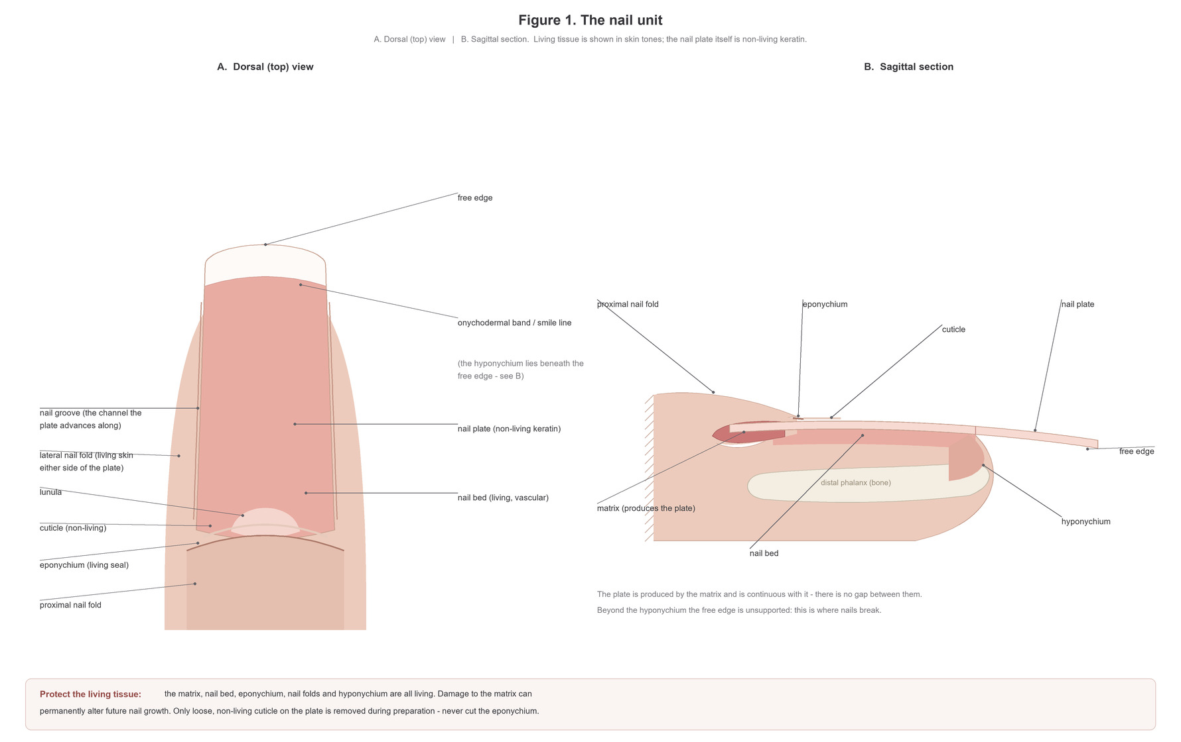
Figure 1. The nail unit. A: dorsal view. B: sagittal section. The matrix produces the nail plate and is continuous with it. The free edge beyond the hyponychium is unsupported.
Original illustration © The Looking Glass Beauty School, 2026.

Structures and functions
Structure | Function and professional relevance
Matrix | Living growth tissue beneath the proximal nail fold. Matrix cells divide, flatten and keratinise to form most of the nail plate. Significant injury can alter future nail growth; the matrix must never be deliberately filed, cut or probed.
Nail plate | The visible, hard but flexible keratin structure. It contains no blood vessels or nerves. Its layers can be thinned or delaminated by over-filing, peeling product, trauma and repeated dehydration.
Nail bed | Living, vascular tissue beneath the plate that supports and anchors it as it advances. It contributes to the pink appearance of a healthy attached nail. Separation of plate from bed is onycholysis.
Proximal nail fold / proximal nail wall | Living skin at the base of the nail that protects the emerging plate and matrix. It is not 'dead cuticle' and should not be aggressively pushed back or cut.
Lateral nail folds / nail walls | Living skin along each side of the plate. They protect the nail unit and guide the plate. Filing into these folds can cause pain, breaks in the barrier and infection risk.
Cuticle | Thin non-living tissue shed from the underside of the proximal nail fold and carried onto the plate. Only loose or adhered non-living tissue is gently removed during preparation.
Eponychium | Living tissue associated with the proximal nail fold and protective seal. It is often incorrectly called the cuticle. Do not cut it simply to create a visually 'clean' margin.
Lunula | The visible pale crescent of the distal matrix on some nails, most obvious on thumbs. Its visibility varies and absence from view is not automatically abnormal.
Hyponychium | Living tissue beneath the free edge where the nail bed ends. It forms a protective barrier. Do not dig under, cut or separate it while cleaning or shortening the nail.
Free edge | The part of the plate extending beyond the fingertip. It can be shortened and shaped while the finger and sidewalls are supported.
Nail grooves | Channels at the sides in which the plate advances. Product should not be flooded into these areas.
Onychodermal band | The transition between nail bed and hyponychium, sometimes visible as a narrow colour change beneath the plate. It is part of the distal protective seal.

How the nail grows
New nail-plate cells are produced in the matrix. As cells mature they flatten, lose their nuclei, fill with keratin and are pushed distally over the nail bed. A fingernail commonly grows at around 3 mm per month, although the rate varies between people, fingers and seasons. A completely new fingernail may take roughly four to six months to grow from matrix to free edge. Growth may be slower with age, illness, impaired circulation, nutritional deficiency, some medication and significant trauma. Use a range and explain variation rather than promising an exact regrowth date.

Factors that can influence nail appearance and growth
- Local trauma: crushing, repeated tapping, biting, picking, over-filing and forced product removal can affect the plate, bed or matrix.
- Water and chemicals: repeated wetting/drying, detergents and solvents can contribute to brittleness and delamination.
- General health: illness, fever, inflammatory skin disease, anaemia and other conditions may be associated with nail changes, but a nail professional must not diagnose the cause.
- Medication and medical treatment: some medicines and treatments can change growth, colour, thickness or fragility. Record only information relevant to treatment safety and refer when the change is new or unexplained.
- Age and individual variation: ridging, thickness and growth rate vary. A difference is not automatically disease, but a sudden or marked change should not be concealed.
- Product and technique: incorrect preparation, incompatible lamps, skin contact, thick coats, aggressive removal and excessive enhancement length can damage or destabilise the service.

Protecting the natural nail
- Use the least abrasive preparation permitted by the product manufacturer. Do not 'etch' grooves into the plate.
- Support the finger and use light, controlled strokes. Stop if the client reports heat, pain or tenderness.
- Keep uncured gel away from all skin and from the underside of the free edge unless the system specifically directs otherwise.
- Never use the enhancement as a tool to prise, scrape or pick. Preventing mechanical trauma is part of aftercare.
- If the nail plate is visibly thin, sore or over-filed, postpone coating and allow recovery rather than hiding the damage.

Chapter 4 — Nail diseases, disorders and recognition
Observe, record, decide and refer — never diagnose
A disease is a pathological process such as infection or inflammatory illness. A disorder or nail change may be traumatic, congenital, behavioural or associated with general health. The categories overlap, and appearance alone is not enough to diagnose. A nail professional should describe what is seen, ask relevant questions, decide whether treatment is safe and refer when uncertain.
FOUR-STEP DECISION — OBSERVE the nail and surrounding skin. ASK when it began, whether it hurts or itches, and whether it is changing. DECIDE whether to proceed, adapt or postpone within your competence and insurance. RECORD the decision and REFER when there is infection, inflammation, unexplained change, pain, broken skin or uncertainty.

Core diseases and disorders
Condition or change | What may be observed | Professional action
Onychomycosis (fungal nail infection) | Thickened, brittle, crumbly or discoloured nail; debris; lifting may occur. Psoriasis and trauma can look similar, so visual inspection is not a diagnosis. | Do not apply or reapply an overlay. Avoid cross-contamination, use single-use items appropriately and advise the client to seek pharmacist, GP or podiatry advice. Treatment is medical, not a salon service.
Onycholysis | Separation of the nail plate from the bed, often beginning distally. The detached area appears white, grey or discoloured. Causes include trauma, psoriasis, fungal infection, irritants and other conditions. | Do not cover active, extensive, painful, discoloured or unexplained separation. Keep the area dry, avoid probing under the plate and refer. A stable, diagnosed residual change may be treated only with insurer approval and no contraindication.
Onychophagy (nail biting) | Short, irregular free edge; surrounding skin may be picked, sore or broken. Severity varies.
Nail psoriasis | Pitting, thickening, colour change, crumbling, onycholysis or oil-drop/salmon patches may occur. It is inflammatory and not contagious. | Do not diagnose. Avoid treatment during an active painful flare, where skin is broken, or where the presentation is uncertain. Stable diagnosed psoriasis may sometimes be treated with medical/insurer guidance and gentle technique.
Paronychia | Red, swollen, warm and tender nail fold; pus may be present. It may be acute bacterial infection or chronic inflammation associated with repeated wet work. | Refuse treatment. Do not drain, cut, massage or cover the area. Advise prompt pharmacy/medical assessment, especially if pain, pus, spreading redness or systemic illness is present.
True pterygium | Scar-like adhesion or abnormal forward growth of tissue involving the nail unit. Dorsal pterygium can split or narrow the plate; pterygium inversum affects tissue beneath the free edge. | Do not confuse true pterygium with ordinary cuticle. Do not cut or push adherent living tissue. Refer for medical assessment before cosmetic coating.
Onychogryphosis (thick dystrophic nail) | Marked thickening, curvature and distortion of the nail, which may trap debris or be difficult to cut. It usually affects toenails and is often associated with pressure, age or neglect. | A builder gel overlay is inappropriate. Do not aggressively file or coat. Refer to a podiatrist/medical professional, especially where diabetes, poor circulation, pain or infection risk is present; do not attempt aggressive reduction unless separately qualified and insured.
Brittle or splitting nails (onychoschizia/onychorrhexis) | Peeling layers, transverse splitting or longitudinal ridges/splits. Repeated water/chemical exposure and trauma can contribute; systemic causes are also possible. | Mild stable brittleness with intact skin may receive a carefully built, short overlay if suitable. New, severe, painful or multiple-nail changes require referral. Do not promise that an overlay will cure the cause.
Koilonychia (spoon nails) | A concave or spoon-shaped plate. It can be congenital, traumatic or associated with health conditions such as iron deficiency. | If new or unexplained, refer. Do not use product to disguise a possible health sign. If longstanding, medically reviewed and intact, treatment may be adapted within insurer conditions.
Duckbill / flared nail shape | The free edge widens or fans outward. This may be the natural growth pattern or result from previous enhancement architecture.
Leukonychia (white spots) | Small opaque white marks commonly follow minor matrix trauma and grow out with the plate. Widespread, powdery or changing white areas can have other causes. | A few stable trauma-related spots on an otherwise healthy nail can usually be coated. Do not diagnose. Refer powdery, spreading, lifting, painful or unexplained changes.
Beau's lines | Transverse depressions caused by temporary interruption of nail growth. They may follow illness, injury or other stress. | If shallow, growing out and the nail is healthy, a gentle cosmetic service may be possible. New, deep, multiple or unexplained lines should be referred.
Splinter haemorrhage | Fine red-brown or black lines beneath the plate, often from minor trauma but sometimes associated with health conditions. | If clearly linked to minor trauma and growing out, record and monitor. Multiple, recurrent or unexplained marks require medical advice. Never cover a suspicious dark streak without referral.
Subungual melanoma warning sign | A new or changing dark longitudinal band, pigment spreading onto surrounding skin, nail destruction, bleeding or a persistent unexplained lesion. | Do not cover. Urgently advise GP assessment. Nail melanoma is uncommon, but delay caused by cosmetic concealment is unacceptable.

Recognising what you are looking at
The photographs below show presentations you may meet at the consultation. Use them to recognise and describe what you see — never to diagnose. Where a nail does not look like any of these, that is itself a reason to pause and refer.
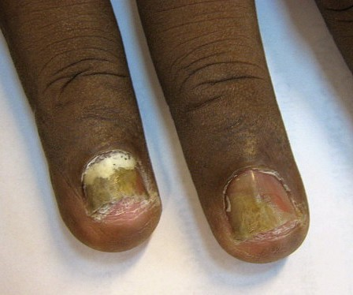
Figure 2. Onychomycosis affecting two fingernails. Yellow-brown discolouration, thickening, crumbling of the plate and separation at the free edge. Do not apply or reapply builder gel — treatment is medical, not a salon service.
Photograph © Grook Da Oger, via Wikimedia Commons, CC BY-SA 3.0.
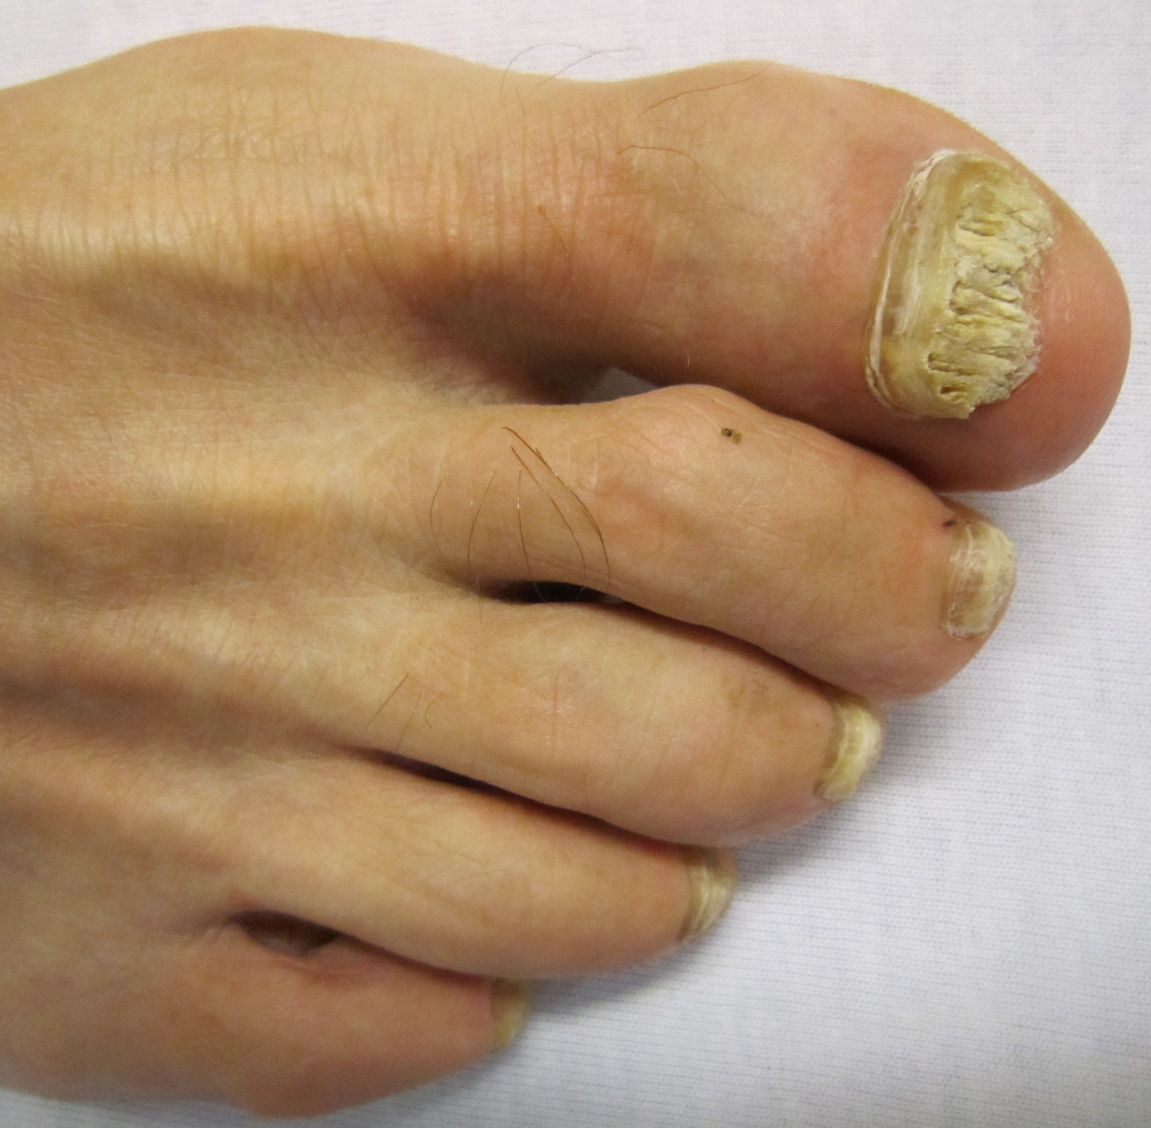
Figure 3. Onychomycosis more commonly affects toenails, as here: marked thickening, yellow-white crumbling and debris beneath the plate. Psoriasis and repeated trauma can look similar — visual inspection is never a diagnosis.
Photograph © James Heilman, MD, via Wikimedia Commons, CC BY-SA 3.0.
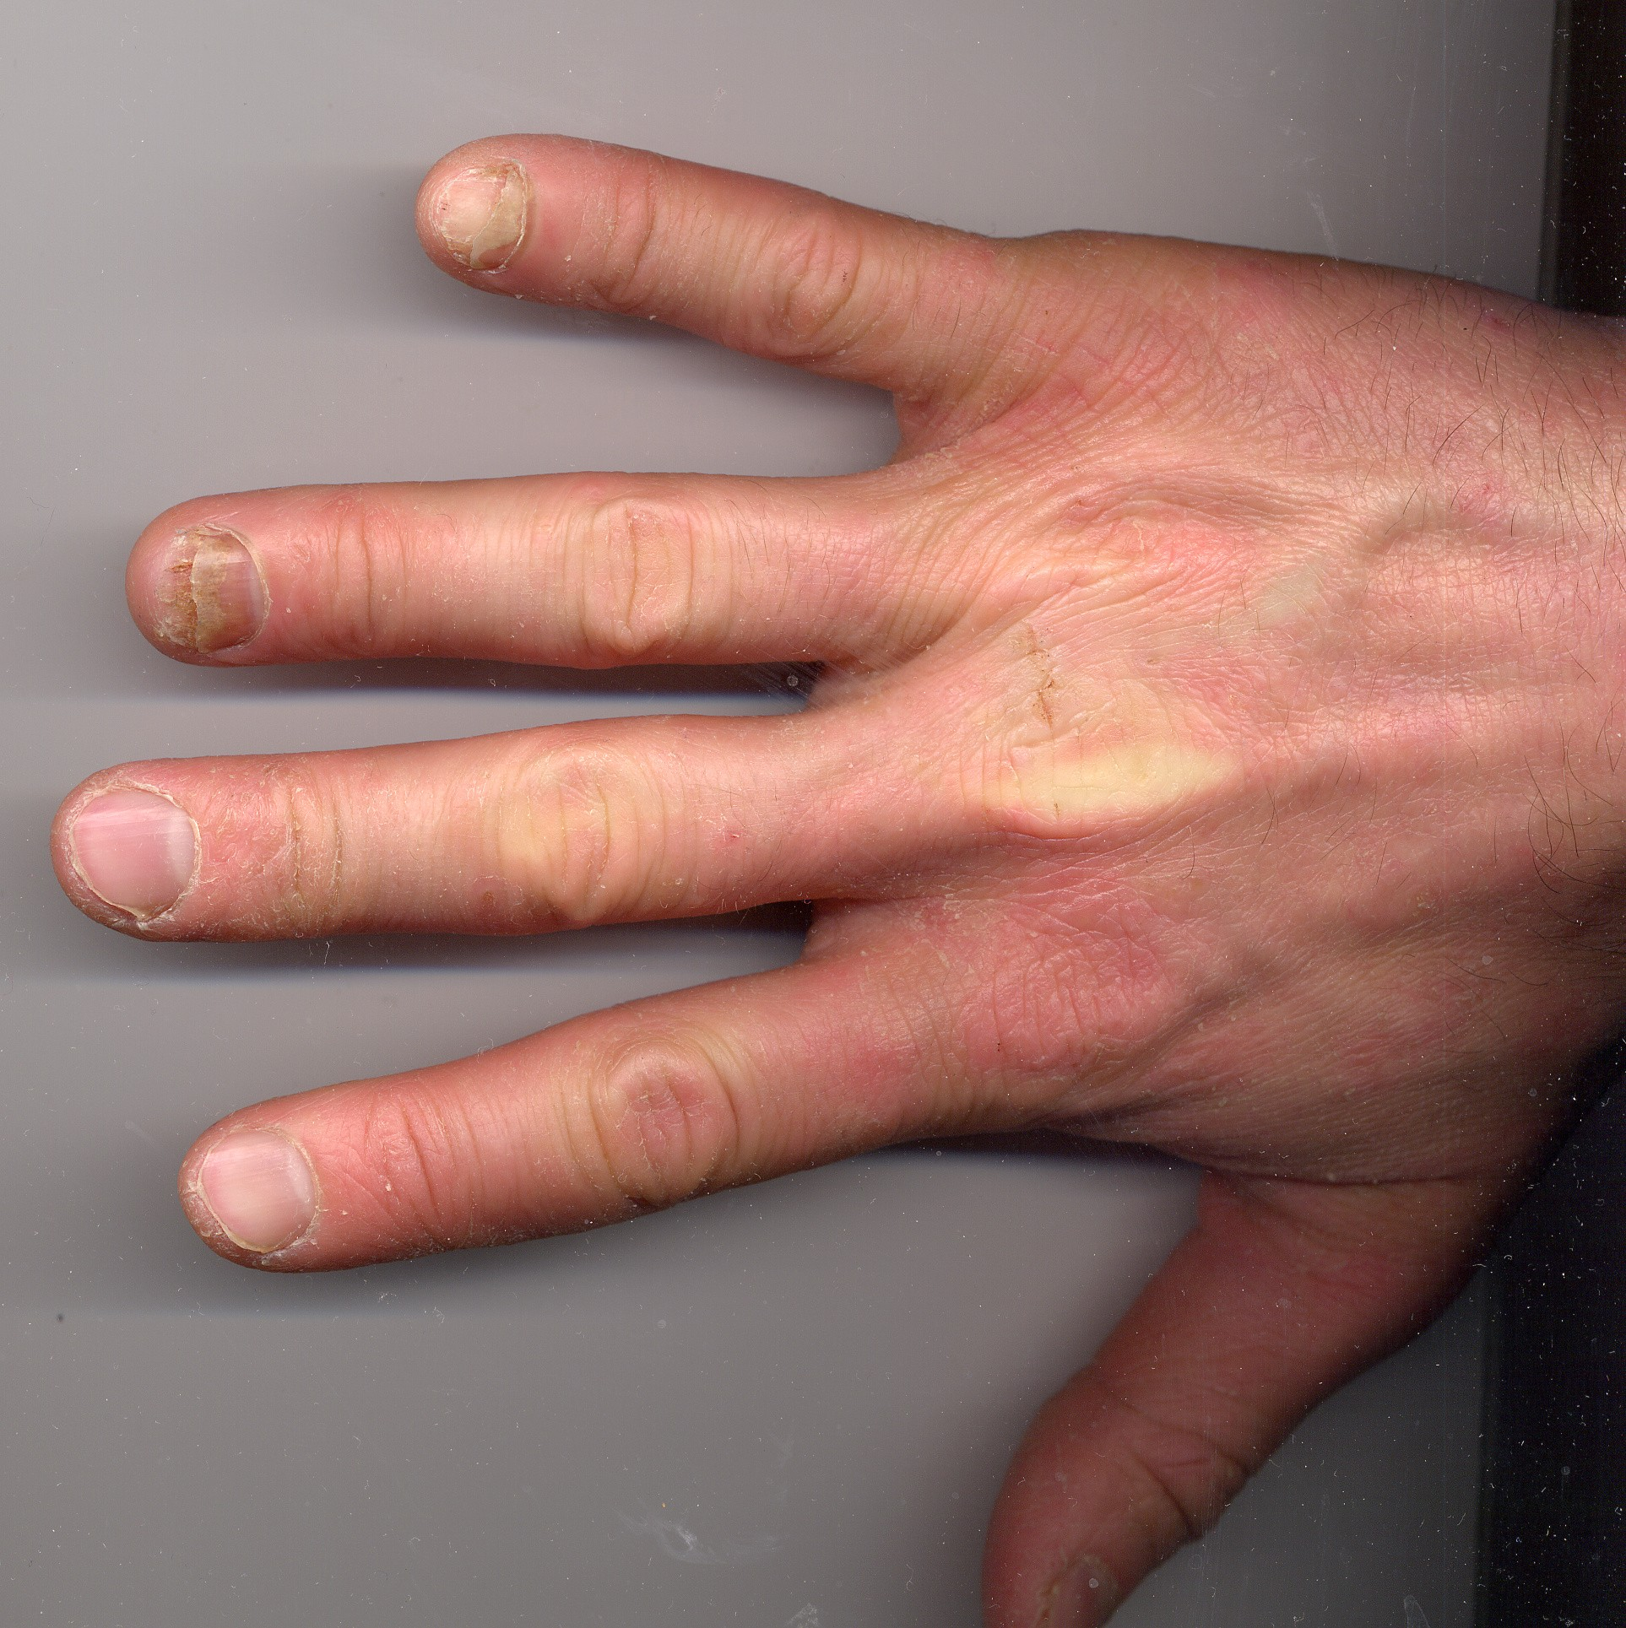
Figure 4. Onycholysis of the ring and little fingernails. The plate has separated from the bed beginning at the free edge, and the detached area appears pale and discoloured. Do not cover active, extensive or unexplained separation.
Photograph © CopperKettle, via Wikimedia Commons, CC BY-SA 3.0.
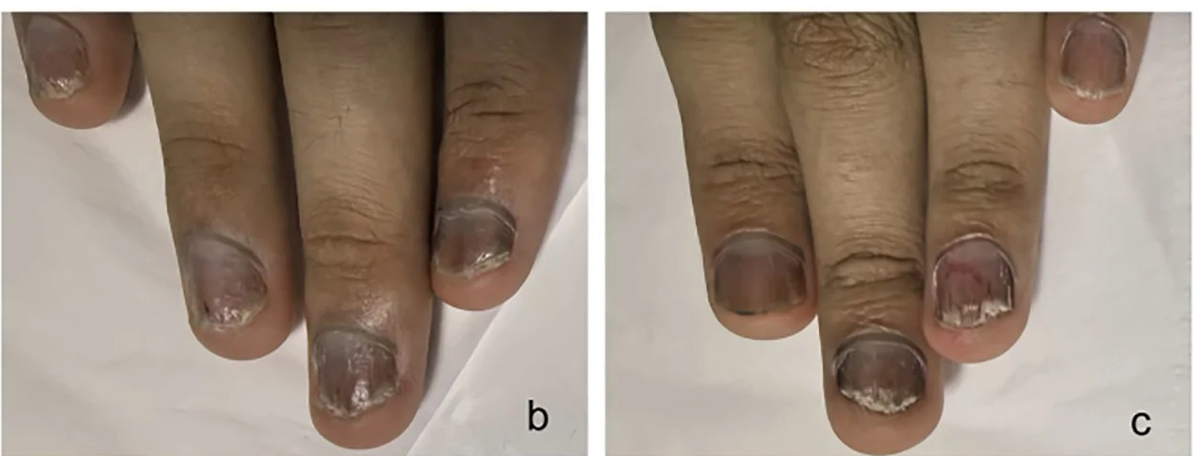
Figure 5. Nail psoriasis. Crumbling of the plate, subungual debris, colour change and separation at the free edge. Psoriasis is inflammatory and not contagious, but it can look very like fungal infection — which is exactly why appearance alone is never a diagnosis. Avoid treatment during an active flare, where skin is broken, or where the presentation is uncertain.
Photograph © Huang Y & Wen S, Frontiers in Immunology (2026), doi:10.3389/fimmu.2026.1941127, CC BY 4.0, cropped. Paediatric patient.
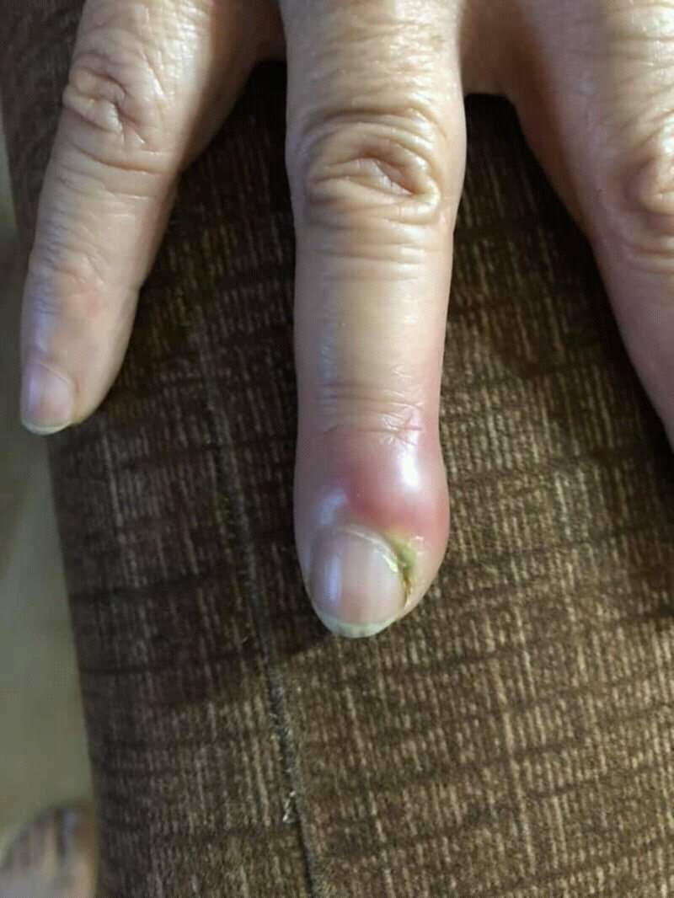
Figure 6. Acute paronychia. The nail fold is swollen, red and tender, with pus present. Refuse treatment. Do not drain, cut, massage or cover the area; advise prompt pharmacy or medical assessment.
Photograph © Mohammad2018, via Wikimedia Commons, CC BY-SA 4.0.
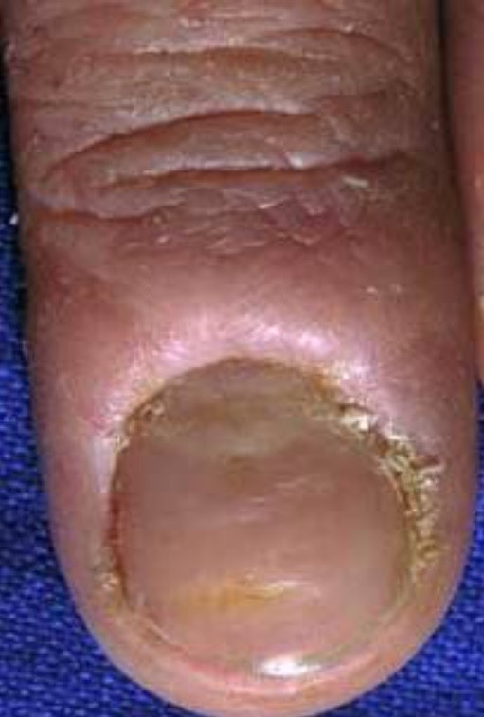
Figure 7. Chronic paronychia. The cuticle seal is lost, the proximal nail fold is thickened and bolstered, and the plate shows ridging and colour change. Commonly associated with repeated wet work.
Photograph © Daifallah M. Al Aboud, M.D., via Wikimedia Commons, CC BY 4.0.
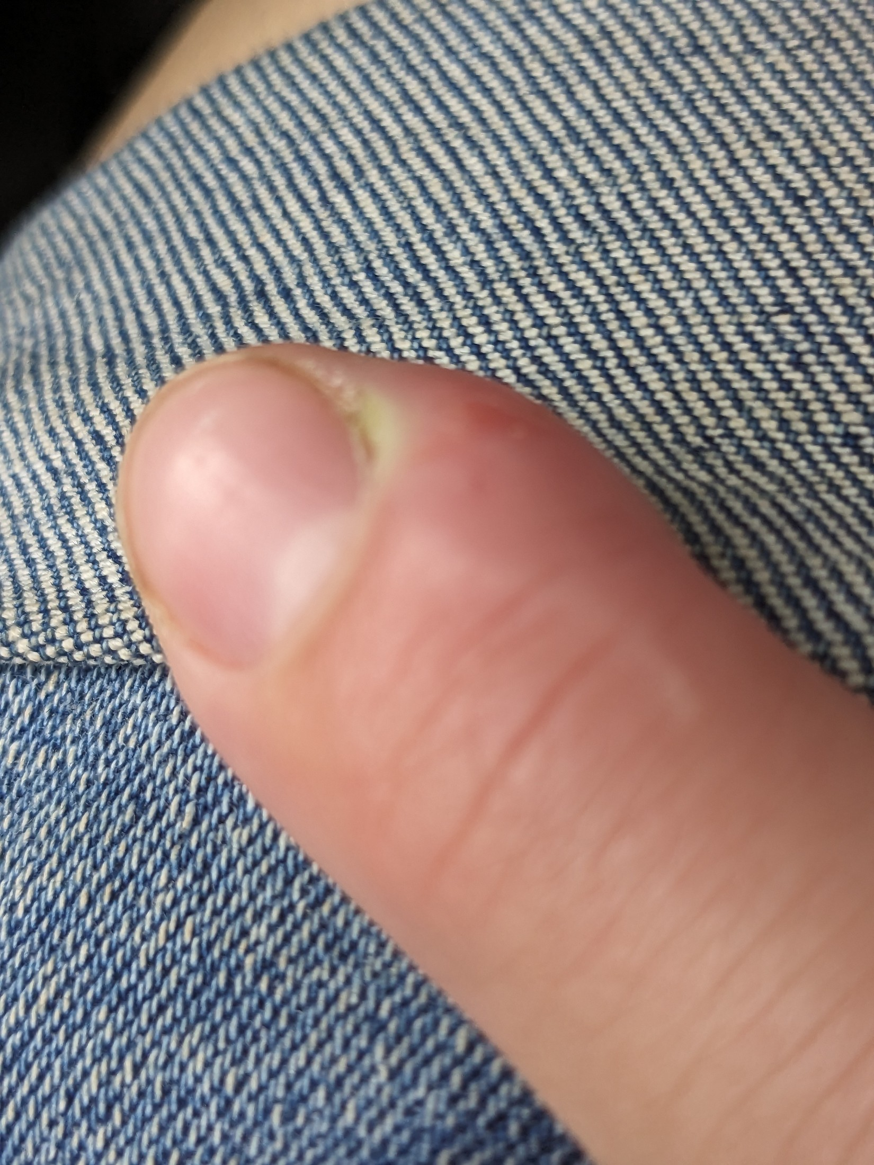
Figure 8. Early paronychia. Localised swelling and a small pus point at the nail fold, with the skin barrier already broken. Even at this stage the service is refused and the client referred.
Photograph © Hannah Clover, via Wikimedia Commons, CC BY 4.0.
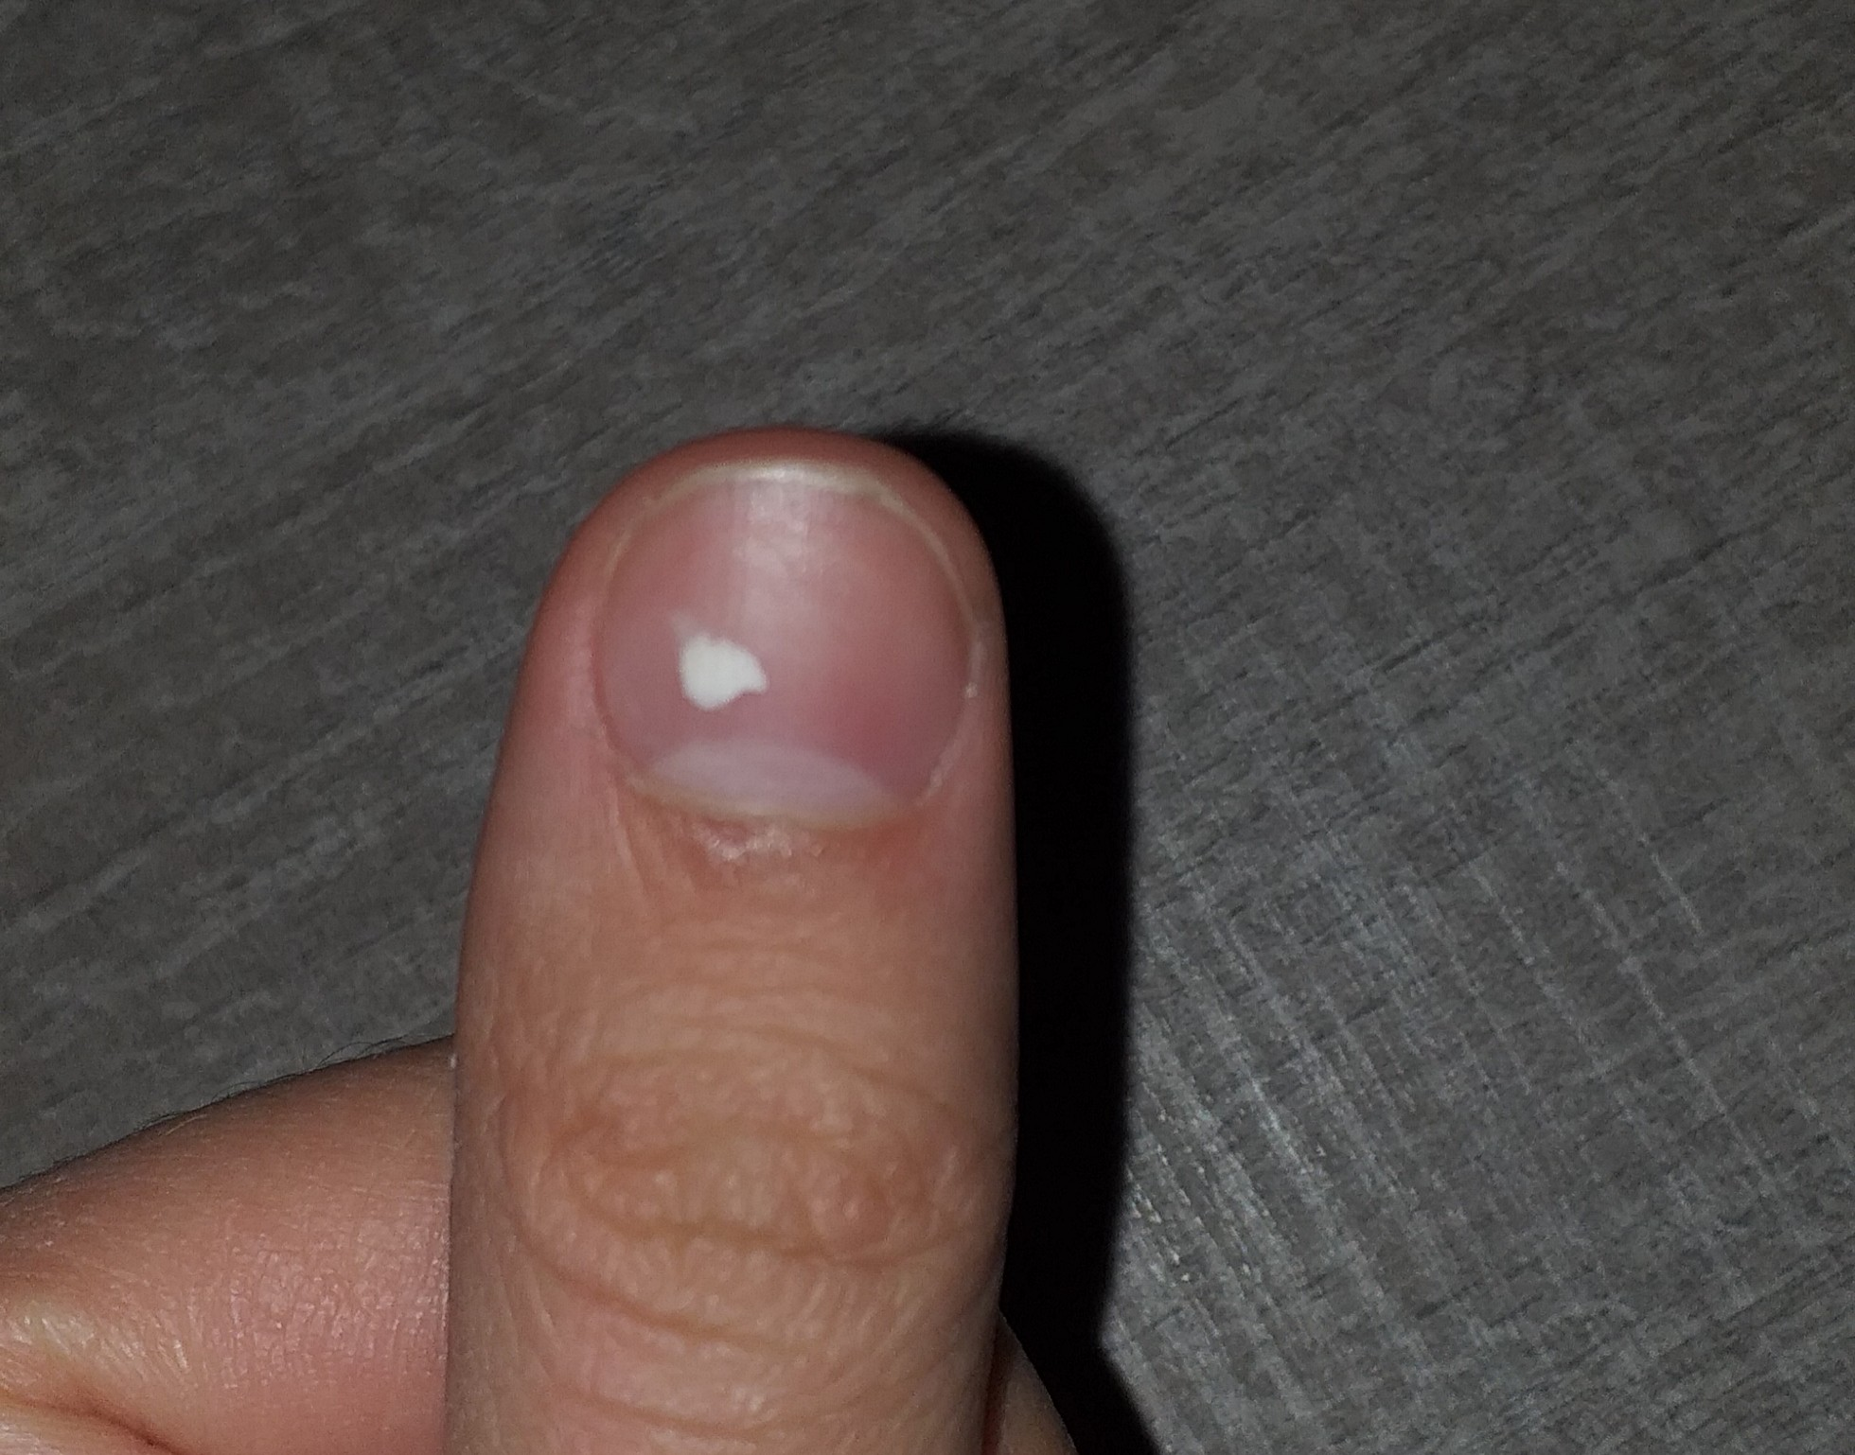
Figure 9. Leukonychia punctata. A single opaque white spot following minor matrix trauma, which grows out with the plate. A few stable spots on an otherwise healthy nail can usually be coated — but do not diagnose.
Photograph © BrotherLongLegs, via Wikimedia Commons, CC BY-SA 4.0.
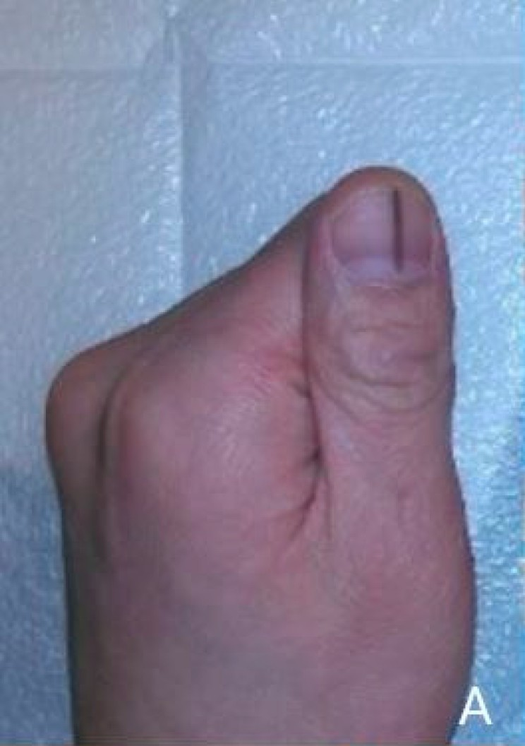
Figure 10. Longitudinal melanonychia — a dark band running the length of the plate. DO NOT COVER. A new or changing band, pigment spreading onto the surrounding skin, nail destruction or bleeding requires urgent GP assessment.
Photograph © Seungjun Lee & Seokchan Eun, via Wikimedia Commons, CC BY 4.0.

Green nail and suspected bacterial infection
Green, green-black or yellow-green discolouration beneath a lifted coating is commonly associated with colonisation by Pseudomonas bacteria in a moist space, although colour alone cannot confirm the organism. It is not correctly described as 'green fungus'. The professional response is not to hide the stain or prescribe a home chemical remedy.
- Stop the service and do not apply fresh product over the discolouration.
- If an existing enhancement can be removed without cutting skin or over-filing, remove it using the correct product method and within competence. If safe removal is uncertain, refer to a suitably qualified professional.
- Keep the nail clean and dry. Do not dig under separated plate, buff away colour or use household bleach, neat vinegar, antibiotics or another treatment unless directed by a healthcare professional.
- Advise the client to seek medical or pharmacy advice, particularly where there is pain, swelling, pus, spreading redness, diabetes, reduced immunity or persistent discolouration.
- Discard contaminated single-use items, quarantine reusable tools and complete the full cleaning/disinfection or validated sterilisation process required by the risk assessment. Record the product, affected nails, observations, action and referral.
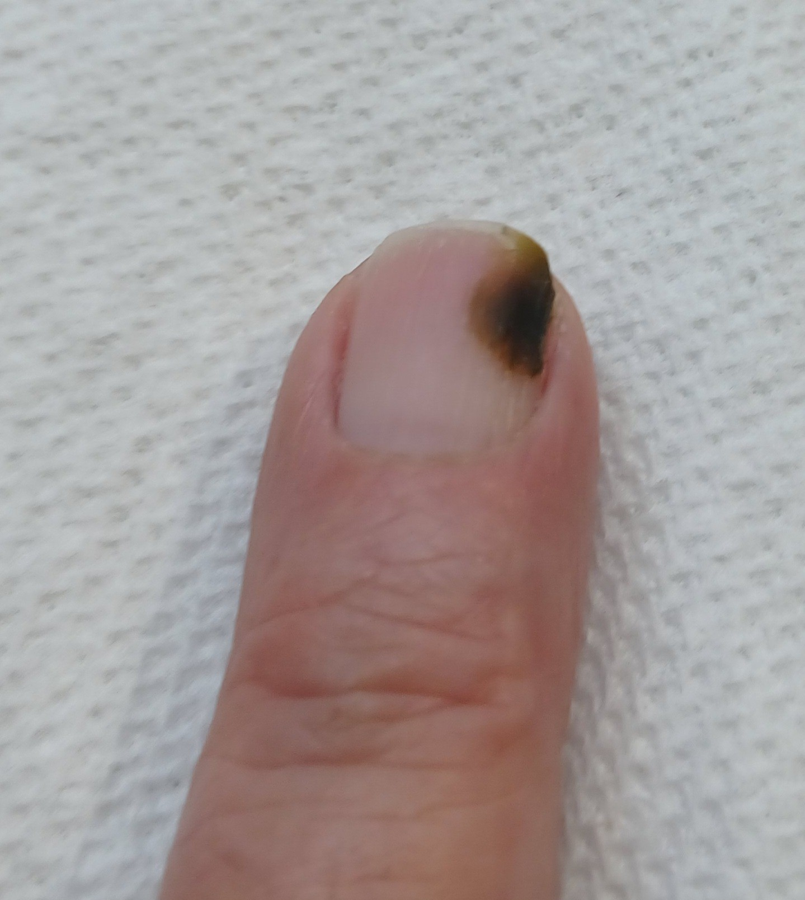
Figure 11. Green nail (chloronychia). Green-black discolouration associated with bacterial colonisation in a moist space. It is not 'green fungus'. Do not apply fresh product over the discolouration.
Photograph by Ekem, via Wikimedia Commons, CC0 1.0 (public domain dedication).
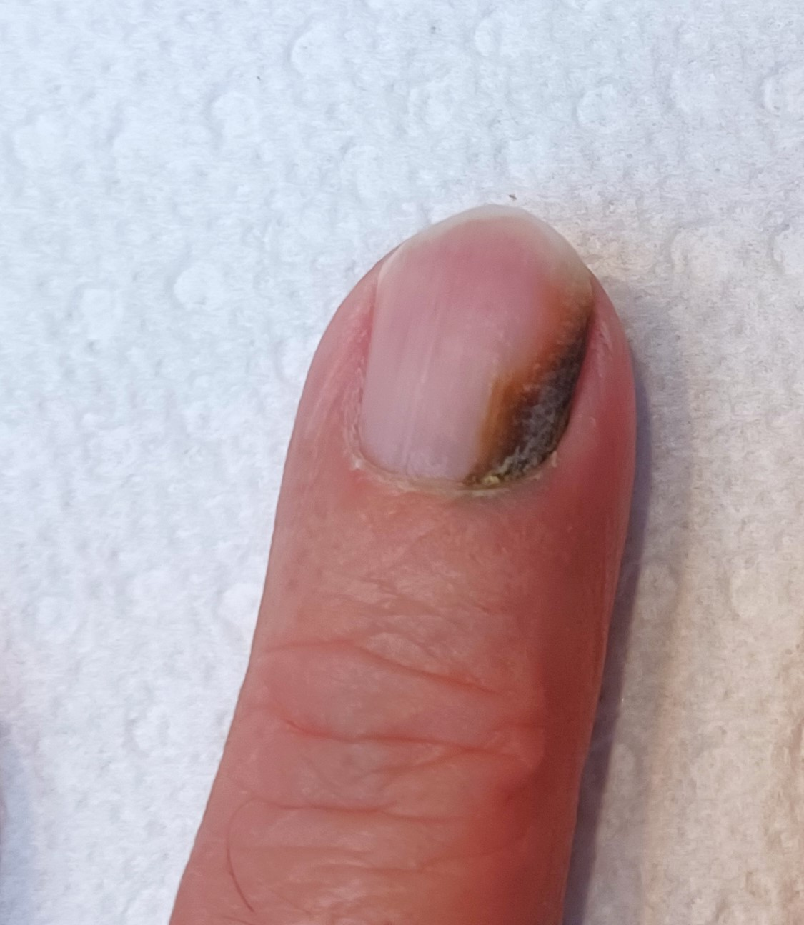
Figure 12. Green nail with associated onycholysis. The discolouration sits beneath a separated area of plate. Do not buff away the colour or use household remedies; keep dry, refer, and decontaminate tools.
Photograph by Ekem, via Wikimedia Commons, CC0 1.0 (public domain dedication).

Contraindications that are not diagnoses
The following findings or circumstances can prevent or restrict a builder gel service even when no named nail disease has been diagnosed:
- Known or suspected acrylate/methacrylate allergy, or a previous reaction to gel, acrylic, nail glue or adhesive products.
- Active eczema, dermatitis, psoriasis flare or unexplained rash on the hands, fingers or treatment area.
- Cuts, abrasions, bleeding, burns, blisters, swelling, heat, tenderness or recent trauma around the nail.
- A wart or other contagious lesion where the service could touch or spread it.
- Recent surgery, severe nail damage, significant plate thinning or pain on light pressure.
- A new, changing, unexplained or suspicious colour/shape change.
- A client unable to keep hands safely in the lamp, follow aftercare, communicate discomfort or give informed consent.
- Any medical condition, treatment or medication for which the insurer or manufacturer requires medical advice, adaptation or refusal. Diabetes and pregnancy are not automatic universal bans; assess individually, avoid injury and follow insurer/product guidance.
DO NOT USE GP LETTERS AS A BLANKET TRANSFER OF RESPONSIBILITY — A doctor's note does not make an unsuitable treatment safe and does not override the professional's competence, product instructions or insurance. Ask only for relevant confirmation, make your own treatment decision and record the rationale.

Chapter 5 — Consultation, treatment planning and consent
A safe service begins before the product is opened

Purpose of the consultation
A consultation is a structured two-way conversation and assessment. It establishes what the client wants, whether the treatment is appropriate, how it should be adapted and whether the client understands costs, maintenance, limitations and risks. A signed form supports the process but is not a substitute for observation, professional judgement or dialogue.

The consultation sequence
- Create privacy and explain why relevant questions are being asked. Confirm the client's identity, age and preferred communication needs.
- Clarify the desired result: colour, finish, shape, length, event, workplace requirements, budget and expected maintenance.
- Ask about previous nail services, wear, lifting, removal methods, reactions, allergies and whether any nails are painful or changing.
- Collect only health and medication information that is relevant to treatment safety. Explain that health data is sensitive and how it will be protected.
- Visually and manually assess the nail plate, free edge, folds, surrounding skin and each hand. Compare nails; do not conceal suspicious findings.
- Identify contraindications and decide to proceed, adapt, postpone or refuse. Explain the reason respectfully without diagnosing.
- Agree a realistic treatment plan, product system, compatible lamp, colour, shape, service time, price, removal/maintenance and aftercare.
- Explain foreseeable risks including temporary dryness, heat sensation, lifting, chipping, allergy/sensitisation risk and harm from picking or forced removal.
- Obtain treatment consent. Obtain separate, optional consent for identifiable photographs or marketing; refusal of marketing consent must not prevent treatment.
- Record products, batch numbers where practical, lamp model, cure times, observations, adaptations and aftercare. Update the record at every appointment.

Treatment planning
A treatment plan converts consultation findings into a safe, individual service. It should be specific enough that another competent professional can understand what was agreed and what happened.
Planning area | What to decide and record
Client goal | Colour/finish, occasion, desired wear, preferred shape and acceptable length
Nail condition | Plate thickness, flexibility, free-edge condition, skin integrity, relevant variations and contraindication decision
Lifestyle | Work, handwashing/wet work, chemicals, sport, gardening, caring, musical instruments, habitual picking and time available for maintenance
System
Adaptation | Shorter length, flexible base, reduced abrasion, one nail excluded, additional removal time, no cuticle nipping or treatment postponed
Service variation
Risk and consent | Benefits, limitations, allergy information, aftercare, cost and separate photo consent
Review | Expected maintenance/removal date, what the client should report, and outcome at the next visit

Consent is informed and ongoing
- The client must understand what will be done, material risks, alternatives and the right to stop. A signature does not remove the duty of care.
- Check consent again if the plan changes, discomfort occurs or another product is proposed.
- Do not use coercive wording such as 'I accept all responsibility'. A professional remains responsible for acting competently.
- For case-study photographs, obtain model consent for the educational purpose and specify who will see the images, how long they will be kept and whether the face/identity will be excluded.
- If consent cannot be freely and clearly given, do not treat.

Consultation scenario
LEARNER ACTIVITY — A client asks for long almond nails for a warehouse job, reports that previous gel 'always lifts', and has a sore split beside the index nail. Identify the immediate contraindication, the lifestyle issue, the questions you would ask and a realistic alternative plan. Record your answer before discussing it with the group.

Chapter 6 — Gel chemistry, curing science and the heat spike
Why product control and lamp compatibility protect clients

Monomers, oligomers and polymers
A monomer is a relatively small reactive molecule that can join with other molecules during polymerisation. An oligomer is a short pre-built chain containing reactive groups. A polymer is a much larger chain or network created when many reactive units join. Light-cured nail gels are normally formulated with a mixture of oligomers, monomers, photoinitiators, pigments and additives. The exact chemistry varies by product.
In a liquid-and-powder acrylic system, the powder is largely pre-polymerised particles and the liquid contains reactive monomer. In a gel system, the reactive mixture is supplied as a premixed gel and requires a suitable light source. This is why the terms 'monomer' and 'polymer' apply to both systems even though the application methods are different.
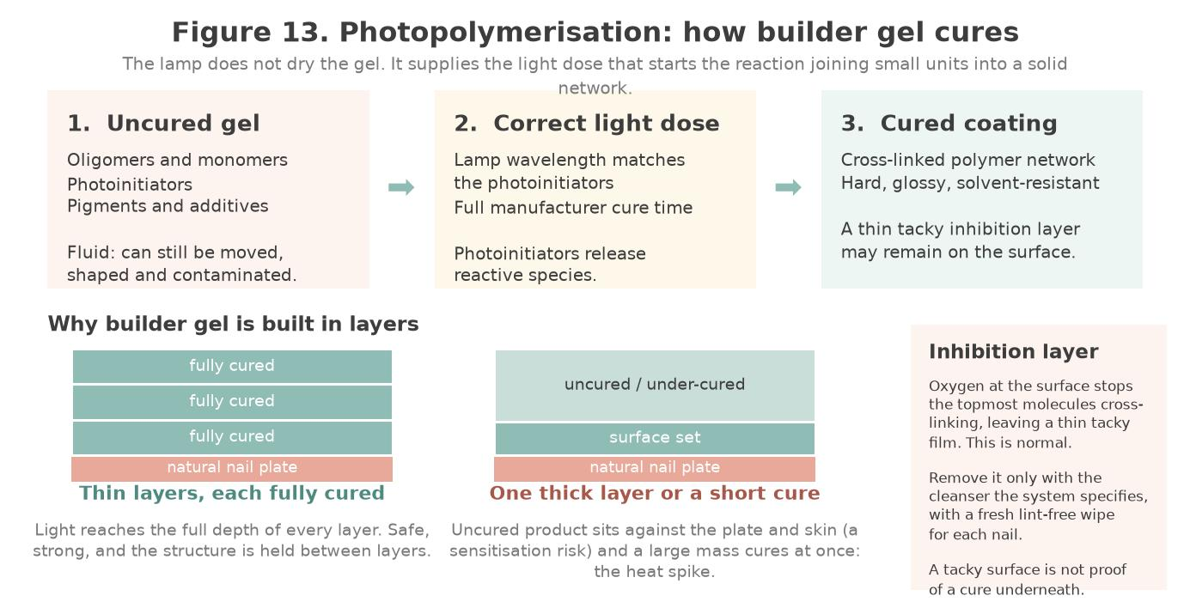
Figure 13. Photopolymerisation. The lamp supplies a light dose, not heat drying. Thin layers cure through their full depth; thick layers or shortened cure times leave uncured product against the plate and skin.
Original illustration © The Looking Glass Beauty School, 2026.

What happens during curing
- The compatible lamp emits light at wavelengths that the product's photoinitiators can absorb.
- Activated photoinitiators generate reactive species that start chain growth and cross-linking.
- The gel changes from a movable liquid/viscous material into a solid polymer network. This reaction releases heat.
- A visually hard surface is not proof of adequate cure throughout the layer. Excess thickness, unsuitable wavelength, weak/dirty equipment, poor hand placement or shortened time can leave more residual reactive material.
- Cure is a system property: product formulation, layer thickness, pigmentation, lamp output, exposure time and hand position all matter.

The inhibition layer
Many light-cured gels have a tacky surface after curing because oxygen at the surface inhibits part of the free-radical reaction. This is called the oxygen-inhibition layer. It is not evidence that all product beneath it is uncured and it is not accurately described as monomer being 'pushed to the top'. Depending on the system, the tacky surface either supports bonding of the next layer or is removed at the end using the specified cleanser. No-wipe top coats are formulated to finish without a noticeable tacky layer.

UV and LED lamps
Both traditional fluorescent UV lamps and modern LED nail lamps emit ultraviolet radiation used for curing. 'LED' describes the light source, not a completely different non-UV process. A lamp may emit around one or more wavelength bands, and the gel must be formulated for that output.
Requirement | Safe practice
System compatibility | Use the lamp identified or approved by the gel manufacturer. Do not assume a lamp will cure another brand because the bottle feels hard.
Wattage | The course uses a professional lamp of 48 W or higher where the selected system specifies it. Wattage is electrical power, not proof of wavelength or curing dose, so never select a lamp on watts alone; compatibility, wavelength, cure schedule and lamp maintenance always take priority.
Cure timing | Use the exact time for each product and layer. Do not shorten time to speed up the service and do not improvise extra-long cures as a substitute for thin coats and compatibility.
Hand position | Place fingers flat, centred and fully inside; reposition thumbs if the design requires. Crooked fingers can move nails away from the effective light area.
Maintenance | Keep reflective surfaces clean, inspect cable/plug/housing, follow bulb or device-life guidance, record faults and remove defective equipment from use.
Client information | Explain that lamps emit UV. Evidence on long-term skin-cancer risk from typical use is limited and evolving; discuss reasonable optional precautions without claiming zero risk.
Optional UV precaution | A client concerned about UV exposure can discuss fingerless UV-protective gloves or broad-spectrum sunscreen applied in advance, provided products do not contaminate the nail plate and the manufacturer's process is not compromised.

NEVER MIX AND HOPE — A base coat, colour, top coat and lamp are a chemical system. If a manufacturer has not confirmed cross-brand compatibility, do not mix products or substitute the lamp during an assessed treatment.

Under-curing and sensitisation risk
Uncured and inadequately cured (meth)acrylate ingredients are more likely than a fully cured polymer to contact and sensitise skin. Repeated exposure can lead to allergic contact dermatitis. Once sensitised, a person may react to very small amounts and cross-reactions can affect future dental or medical materials. Prevention centres on keeping uncured product off skin, using compatible systems, curing correctly and reducing occupational exposure.
- Apply thinly and evenly; remove every trace from skin before curing.
- Never use a gel product to perform a skin patch test. 'HEMA-free' does not mean acrylate-free or allergy-proof.
- Do not touch inhibition layers with bare fingers. Use lint-free wipes once and discard safely.
- Do not use hands or fingernails as tools for cleaning gel from brushes, bottles or equipment.
- Wear task-appropriate PPE identified by the COSHH assessment/SDS and change contaminated gloves immediately.
- Monitor technicians' skin and respiratory health; act early on itching, cracking, rash, eyelid/facial eczema, cough or wheeze.

The principal allergens: HEMA and di-HEMA TMHDC
HEMA (2-hydroxyethyl methacrylate) and di-HEMA TMHDC (di-HEMA trimethylhexyl dicarbamate) are the methacrylates most often implicated in gel nail allergy. Under Regulation (EU) 2020/1682, as retained in the GB Cosmetics Regulation, nail products containing these ingredients are restricted to professional use only and must be labelled "For professional use only" and "Can cause an allergic reaction". The two main sensitisation routes are uncured product touching skin and product that has been under-cured. The British Association of Dermatologists has warned of a UK (meth)acrylate allergy epidemic, which is why skin-contact avoidance and correct curing are treated as safety-critical throughout this course. Remember that 'HEMA-free' does not mean acrylate-free or allergy-proof: other reactive ingredients can also sensitise.

Photoinitiator regulation: TPO
TPO (trimethylbenzoyl diphenylphosphine oxide) is a photoinitiator that was formerly common in gel systems. It has been classified as a category 1B CMR substance (toxic to reproduction). It is banned in the EU and Northern Ireland from 1 September 2025, including continued professional use of existing stock. In Great Britain, the Cosmetic Products Regulation (EC) No 1223/2009 (Restriction of Chemical Substances) (Amendment and Transitional Provisions) Regulations 2026 (SI 2026/23) add TPO to Annex II (prohibited substances) with transition periods: no new TPO products may be placed on the GB market after 15 August 2026, and existing compliant stock may continue to be made available and used until 14 February 2027. Because the law is in transition, professionals must check ingredient lists for TPO, verify reformulated products with their suppliers, and confirm the current legal position at each course review and before purchasing stock.

What changes when the layer gets thicker
The chemistry of builder gel is the chemistry already described in this chapter. What changes is scale. A gel-polish colour coat is a fraction of a millimetre; a builder-gel structural layer may be many times that. Three consequences follow.
Consequence | Why it happens | What you do about it
Light has further to travel | The lamp must cure through the whole depth, not just the surface. A set surface over uncured product is the classic thick-layer failure. | Build in layers the manufacturer specifies. Never pour on one thick layer to save time.
More material reacts at once | Polymerisation releases heat. More product means more heat released in the same few seconds. | Thin layers, and use a flash cure or a low-heat lamp setting where available.
The product can move before it cures | Self-levelling formulas flow. Gravity acts on them while you work. | Control the nail position, and cure at the moment the structure is where you want it.

The heat spike
A heat spike is a sudden sensation of burning under the nail during cure. It is not a minor inconvenience: it is the client's nail bed responding to heat, and it can cause real pain and, in severe cases, separation of the plate from the bed.

Why it happens
- Product applied too thickly, so a large volume cures at once.
- A thin, damaged or over-filed natural nail, which insulates the bed less.
- A high-powered lamp bringing the reaction to its peak faster.
- A client who is already sensitive, or nails that have just been filed.

What to do
- Tell every client before you start what a heat spike feels like and to tell you immediately.
- If the client reports heat, have them remove the hand from the lamp at once. Do not ask them to endure it.
- Allow the nail to cool completely, then return it to the lamp for the remainder of the cure.
- For the next nail, apply a thinner layer, and use a flash cure or low-heat setting if available.
- Record the event and what you changed.
- Agree a stop signal before the first cure, so the client can tell you without having to speak, and record significant heat with the nail, product, lamp and action taken.
NEVER TELL A CLIENT TO SIT THROUGH IT — A heat spike is a warning, not an inconvenience. Pulling the hand out and re-curing costs seconds; a burned nail bed costs months and may lift the plate from the bed.

Chapter 7 — Nail architecture: apex, stress area, C-curve and balance
The part of the job that decides whether the nail lasts
Strength in an enhancement comes from its shape, not its thickness. A correctly shaped nail distributes force through the structure; a badly shaped one concentrates force at a single point and breaks there, however much product has been used.
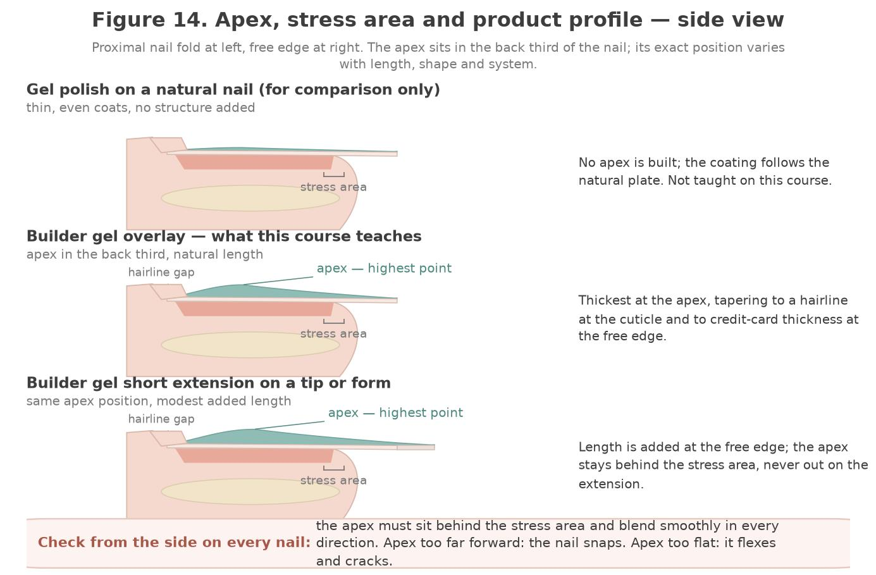
Figure 14. Apex, stress area and product profile, side view. In a builder gel overlay the apex sits in the back third of the nail and is blended smoothly in every direction; the stress area, where the free edge leaves the nail bed, is the point the apex exists to support. Gel polish is shown only for comparison.
Original illustration © The Looking Glass Beauty School, 2026.

The four things a balanced nail needs
Feature | What good looks like | What goes wrong without it
Apex | The highest point of the enhancement, placed in the back third of the nail and blended smoothly in every direction | Apex too far forward: the nail snaps at the stress area. Apex too flat: the nail flexes and cracks. Apex too high: it looks bulbous and catches.
Stress area | The zone where the free edge leaves the nail bed, supported by the apex behind it | Unsupported stress area is where almost all breaks occur.
C-curve | An even transverse curve, consistent from sidewall to sidewall along the length | A flat or uneven C-curve makes the nail weak and the sidewalls look pinched or splayed.
Sidewalls | Straight when viewed from above, meeting the natural sidewall without a step or gap | Product over the sidewall causes lifting and skin irritation; a gap traps moisture and debris.

Thickness
Thickness should be greatest at the apex and taper in every direction. At the cuticle area the product must be whisper-thin so there is no ridge to lift. At the free edge, a useful reference is the thickness of a credit card; thinner and it will chip, thicker and it looks and feels clumsy.

Working in zones
Most educators teach enhancement application, builder gel included, in three zones. The zones are a way of controlling where product goes and how much, not a rigid rule about bead count.
Zone | Where | What it does
Zone 1 | The free edge or the extension beyond the natural nail | Establishes length and shape. Usually placed first when working on a form.
Zone 2 | The stress area and the centre of the nail | Builds the apex and carries the structural load. The most important bead on the nail.
Zone 3 | The cuticle area | Blends the structure to nothing. Thin, neat and never touching living tissue.

CHECK FROM EVERY ANGLE — Look down the barrel of the nail from the free edge to see the C-curve, from the side to see the apex, and from above to see the sidewalls. A nail that looks right from only one angle is not balanced.
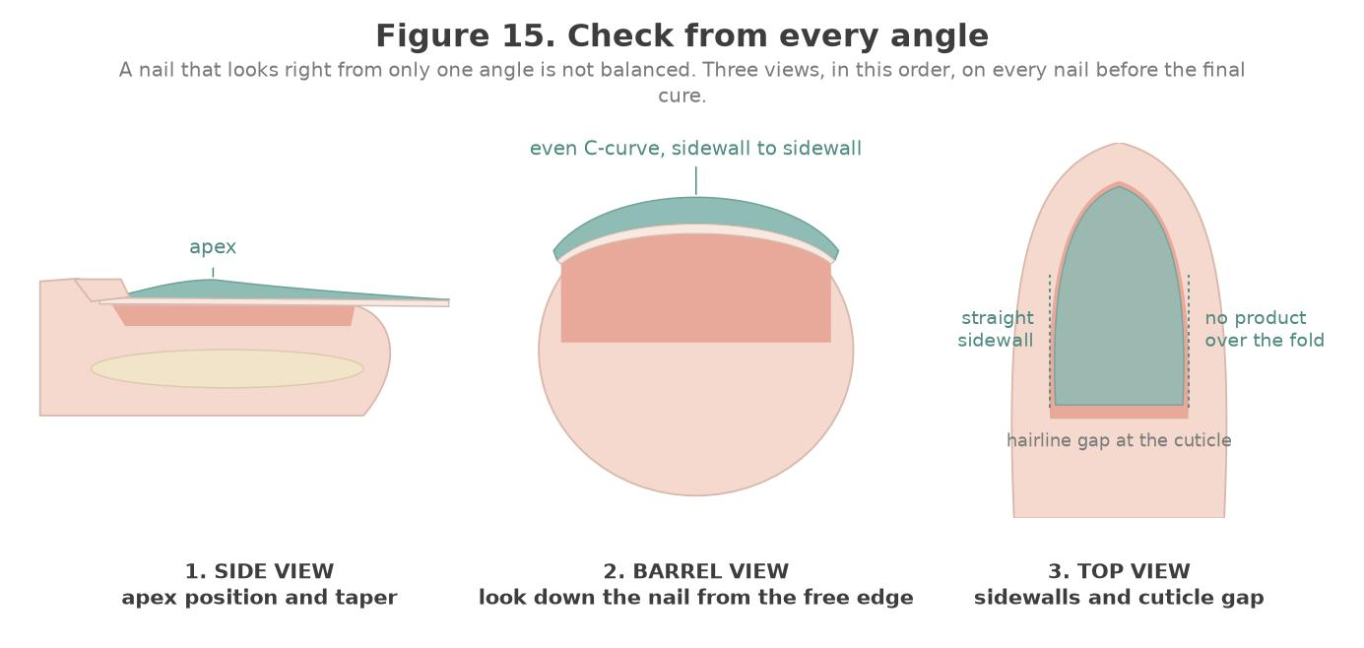
Figure 15. Check from every angle: side view for the apex and taper, barrel view for the C-curve, top view for straight sidewalls and the hairline gap at the cuticle. Done in that order on every nail before the final cure.
Original illustration © The Looking Glass Beauty School, 2026.

Nail shapes and their structural demands
Shape | Structural note
Square | Corners are vulnerable. Keep sidewalls straight and the free edge short enough to survive the client's work.
Squoval | Softened corners reduce snagging while keeping strength. A practical default.
Round and oval | Naturally strong shapes; force is distributed around the curve.
Almond | Needs a well-placed apex and even sidewall taper. Do not thin the sides to create the shape.
Coffin or ballerina | The narrow free edge removes support. Requires a strong apex and a conservative length.
Stiletto | The most demanding shape. Only appropriate for a client whose lifestyle allows it, and only with excellent architecture.
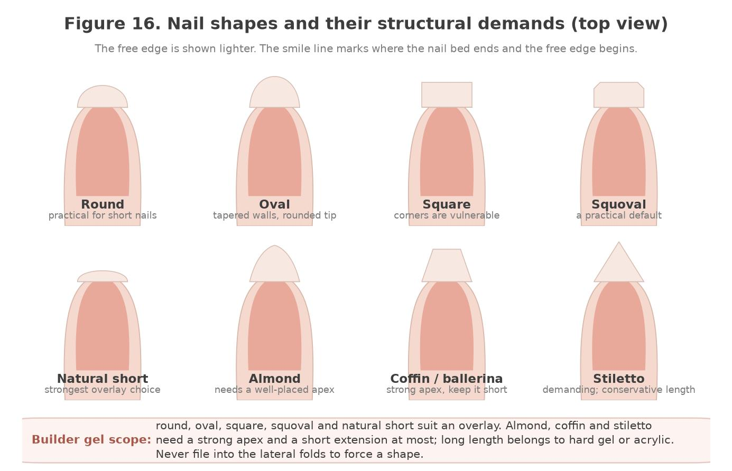
Figure 16. Common nail shapes from above. Round, oval, square, squoval and natural short suit a builder gel overlay; almond, coffin and stiletto demand a strong apex and only a short extension.
Original illustration © The Looking Glass Beauty School, 2026.

Chapter 8 — Kit, equipment, files and product storage
Select the right tool, use it lightly and maintain it correctly
Item | Purpose and safe use
Builder gel | The structural product. Record the exact name, viscosity and removal category. Keep the pot or bottle closed and away from daylight — ambient light begins to cure it.
Compatible lamp | Must match the product's photoinitiators. Record make, model, wattage and the cure schedule per layer. A flash-cure or low-heat setting is valuable for builder work.
Gel brush or spatula | For placing and guiding product. Clean with the product-specified cleanser, never with acetone unless the manufacturer says so.
Nail prep and dehydrator | Applied to the plate only, immediately before product.
Primer or bonder | Product-specific. Acid-free is standard. Apply sparingly, to the plate only.
Slip solution or cleanser | Used to help move self-levelling product. Use only the product the system specifies.
Tips, adhesive and forms | For short extensions. Fitted sidewall to sidewall with no gaps.
Files and buffers | 100/180 combination file for product; 180 grit and finer for the natural nail and refining. Single-client use or fully decontaminated.
Lint-free wipes | Single use, one nail at a time, for the inhibition layer and cleansing.
Local extraction | Where the risk assessment identifies dust or vapour risk from filing.

Files and grits
Grit | Category | Typical use
80–100 | Very coarse | Reducing bulk on cured product only. Never on the natural nail.
100/180 combination | Coarse / medium | The standard enhancement file. The 100 side is for product; the 180 side refines.
180–240 | Medium to fine | Refining the surface and the free edge.
240+ and buffers | Fine to very fine | Removing surface shine from the natural nail, and smoothing before finish. Light pressure only.
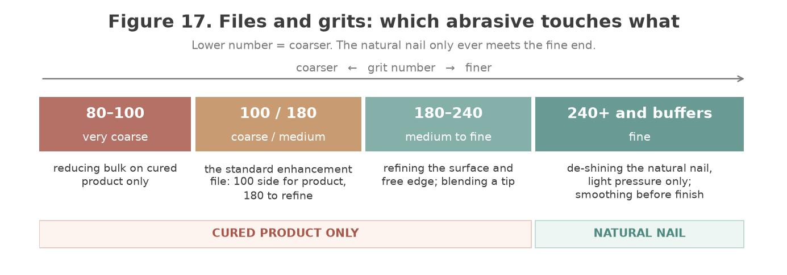
Figure 17. Files and grits. Coarse abrasives touch cured product only; the natural nail meets nothing coarser than 240 grit, and then only to remove shine.
Original illustration © The Looking Glass Beauty School, 2026.

LIGHT AND HEAT SPOIL GEL — Keep bottles closed and out of direct light. Product left open under a desk lamp begins to cure in the bottle and will never perform correctly.

Chapter 9 — Health, safety, hygiene and ergonomics
Preventing exposure, cross-contamination and avoidable injury

Risk assessment and hierarchy of controls
The safest approach removes or reduces a hazard before relying on personal protective equipment. A salon COSHH/risk assessment should consider the product, task, route of exposure, frequency, quantity, ventilation, people at risk and emergency action.
Control level | Builder gel example
Eliminate | Do not stock a recalled/non-compliant product; do not perform an unsafe service.
Substitute | Select a professional compliant system with clear safety information where this reduces risk, while recognising that 'HEMA-free' is not allergy-free.
Engineering control | Use suitable local exhaust/downdraught extraction for dust and adequate general ventilation.
Administrative control | Training, consultation, thin application, closed containers, cleaning schedules, limited exposure time and incident reporting.
PPE | Task-appropriate gloves, eye protection and apron where the assessment/SDS requires them. PPE is the last line, not the only control.

Routes of exposure
Route | Examples | Control
Skin | Uncured gel, inhibition layer, cleanser, acetone, contaminated gloves | No skin contact; controlled application; prompt washing; suitable gloves; hand care
Eyes | Splash, dust, contaminated fingers | No touching face; eye protection for splash/dust tasks; eyewash access; follow SDS first aid
Inhalation | Fine filing dust, vapours and aerosols | Avoid unnecessary dust; local extraction; ventilation; closed containers; suitable RPE only where risk assessment requires
Ingestion | Eating/drinking at workstation, contaminated hands | No food/drink/smoking in treatment area; wash hands before breaks
Injection/cut | Nipper/file injury or contaminated sharp | Protect skin, use tools correctly, stop bleeding service and follow blood-spill procedure

Cleaning, disinfection, sanitation and sterilisation
These terms are not interchangeable. Cleaning physically removes dirt and organic matter and must occur before effective disinfection or sterilisation. Sanitation reduces contamination to an acceptable routine level. Disinfection inactivates many disease-causing microorganisms but may not destroy bacterial spores. Sterilisation is a validated process intended to destroy all viable microorganisms, including spores.
Item/method | Correct approach
Hands/skin | Wash with liquid soap and water when visibly dirty and at the start/end of work; dry thoroughly. Use an appropriate hand rub on visibly clean hands where policy allows. Moisturise between services/after work to protect the barrier.
Work surface and lamp exterior | Clean visible soil, then apply a compatible disinfectant for the stated contact time. Do not spray liquid into electrical equipment.
Porous files, buffers, orangewood sticks | Treat as single-client/single-use unless the manufacturer and local policy provide a validated decontamination route. Do not share between clients.
Metal pusher, nippers, clippers | After every client: safely transport as used, clean with detergent/mechanical action, rinse/dry, inspect, then disinfect using a compatible product at correct dilution/contact time. Sterilise by validated steam autoclave if the risk assessment/local authority requires it.
Blood-contaminated reusable tool | Stop, wear appropriate PPE, quarantine safely and follow the blood/body-fluid procedure. Dispose as appropriate or use a validated cleaning and steam-sterilisation route; do not simply wipe and reuse.
Autoclave | Steam steriliser used only for compatible instruments with validated cycles, packaging/loading, records, routine tests and maintenance. It is the recognised salon method when sterilisation is necessary.
UV cabinet/light box | Storage aid for already clean/decontaminated instruments. It must not be described as a reliable steriliser.
Glass-bead unit, hot-air oven, boiling water | Do not present as validated salon sterilisation. Current local-authority guidance commonly states that glass-bead units, UV boxes, hot-air ovens and boilers must not be used for sterilisation.
Chemical immersion | Usually disinfection in salon use. A product may make a sterilant claim only under specific validated conditions; follow label, COSHH and local rules and do not casually call a disinfectant 'sterilising solution'.

Standard between-client sequence
- Remove used disposables and place them directly into the correct waste container.
- Move reusable tools to a designated closed 'used' container; keep them separate from clean tools.
- Clean and disinfect the workstation, hand rest, lamp touch points and any reusable containers using the correct contact time.
- Perform the full tool-cleaning and disinfection/sterilisation process. Dry, inspect and store protected.
- Wash and dry hands, replace couch roll/towel and set out only the clean items needed for the next client.
- Record completed scheduled cleaning and any contamination incident.

Blood or skin-break procedure
- Stop the service and move products/tools away.
- Ask the client to apply pressure with clean disposable gauze where appropriate; the professional should wear suitable disposable gloves.
- Do not continue gel application over broken skin or active bleeding.
- Dispose of contaminated single-use materials in the route identified by the local waste assessment. Quarantine reusable tools for validated processing.
- Clean and disinfect the contaminated surface using the salon's blood-spill procedure and product instructions.
- Wash hands after glove removal, document the incident and provide appropriate first-aid/referral advice.

Ventilation, dust and odour
HSE guidance for nail bars and beauticians (HSE COSHH Essentials sheet SR13, "Nail bars and other beauty services") identifies dermatitis, skin allergy, asthma and respiratory symptoms as relevant risks from beauty products and artificial-nail dust. General ventilation helps, but opening a window alone may not control dust at the technician's breathing zone. Use source capture where the assessment requires it, maintain filters and use methods that create the least dust.
- Keep bottles closed when not dispensing and clean spills immediately according to SDS.
- Position local extraction close enough to capture dust before it crosses the breathing zone.
- Do not rely on a strong smell to judge danger; some hazardous exposure has little odour, and smell perception varies.
- Do not use an ordinary desk fan that blows dust and vapour across the client or room.
- Empty/maintain extraction and waste in accordance with instructions while wearing any identified PPE.

Ergonomics and prevention of backache/RSI
Area | Good practice
Chair and feet | Use an adjustable supportive chair. Sit back with feet flat or on a footrest; avoid perching or twisting.
Desk and elbows | Use a narrow, stable manicure desk so client and technician do not reach. Support both forearms; aim for relaxed shoulders and elbows near 90 degrees.
Neck and vision | Bring the client's hand into the lit working area instead of bending the neck toward the desk. Consider task lighting or magnification.
Wrist and grip | Keep wrist as neutral as possible, use a light tool grip, support the finger and vary movement. Replace worn files rather than pressing harder.
Client position | Seat the client squarely facing the desk with supported arm and relaxed hand. Ask them not to pull, twist or hold the fingers rigid.
Work pattern | Insert microbreaks, stretch hands/forearms/neck, alternate tasks, schedule realistic service gaps and review symptoms early.
Warning signs | Persistent pain, tingling, numbness, weakness or night symptoms require workload review and appropriate medical/occupational-health advice.

30-SECOND POSTURE RESET — Feet supported; hips back; shoulders down; client close; forearms supported; wrist neutral; lamp and extraction correctly positioned. Reset between every client.

Chapter 10 — UK legislation, insurance, data and advertising
How the rules connect to everyday salon decisions
Legislation changes and local requirements differ. The following summary explains relevance to builder gel work in Great Britain as at August 2026; it is educational guidance, not legal advice. Businesses must check current official sources, insurer terms and their own local authority before delivery and at each document review.

Core legislation and guidance
Law or requirement | Relevance to a builder gel professional
Health and Safety at Work etc. Act 1974 | Creates general duties to protect employees and others, including clients, so far as reasonably practicable. In practice: risk assessments, safe systems, training, maintained equipment, consultation and incident action.
Control of Substances Hazardous to Health Regulations 2002 (COSHH) | Requires employers to assess and prevent or adequately control exposure to hazardous substances. Keep SDS, identify skin/inhalation/eye/fire risks, use control measures, train staff, manage spills and review assessments when products or processes change.
Personal Protective Equipment at Work Regulations 1992, as amended in 2022 | Where risk remains after other controls, employers must provide suitable PPE free of charge, train workers and maintain it. The 2022 amendment extends relevant duties to limb (b) workers. PPE selection must follow the hazard and SDS, not salon fashion.
Reporting of Injuries, Diseases and Dangerous Occurrences Regulations 2013 (RIDDOR) | Specified work-related injuries, dangerous occurrences and diagnosed occupational diseases must be reported by the responsible person. Not every chip, rash or complaint is RIDDOR-reportable. Work-related diagnosed dermatitis can be reportable where the work involves significant/regular exposure to skin irritants or sensitisers. Use HSE's current decision guidance.
Data Protection Act 2018 and UK GDPR | Client contact details, consultation records, health information and photographs are personal data; health data is special-category data. Identify an Article 6 lawful basis and an Article 9 condition, give privacy information, minimise collection, secure records, set justified retention periods, support rights and separate treatment consent from marketing consent.
Cosmetic Products Enforcement Regulations 2013 and retained Cosmetic Regulation 1223/2009, as amended | Cosmetic nail products supplied in GB must meet safety, responsible-person, labelling and notification requirements. Buy through reputable compliant supply chains, keep original labels/batches, act on recalls and do not manufacture, relabel or import products without understanding responsible-person obligations.
Cosmetic Products Regulation (Restriction of Chemical Substances) (Amendment and Transitional Provisions) Regulations 2026 (SI 2026/23, as supplemented by SI 2026/109) — TPO | GB restrictions affecting Diphenyl(2,4,6-trimethylbenzoyl)phosphine oxide (TPO) begin on 15 August 2026 with transitional provisions for products already placed on the market. Existing compliant stock may continue to be made available through 14 February 2027 under the regulation. TPO has already been banned in the EU and Northern Ireland since 1 September 2025. Because interpretation of salon use and supply can be fact-specific, check current OPSS/Trading Standards and supplier guidance before purchase or use.
Local Government (Miscellaneous Provisions) Act 1982 | In England outside London, local authorities can adopt licensing/registration provisions for specified treatments and may impose local byelaws or special-treatment conditions. Coverage differs between authorities, so each business and learner must check the authority where they practise and meet insurer requirements.
London Local Authorities Act 1991 | In London, premises offering nail treatments generally need a Special Treatment Licence, applied borough by borough with local conditions on qualifications, hygiene and premises. Check the relevant borough before trading.
Civic Government (Scotland) Act 1982 | In Scotland, licensing of relevant treatments and premises operates under this Act through the local licensing authority. Check the authority where you practise.
Public Health (Wales) Act 2017 | In Wales, this Act established a special-procedures licensing framework. Nail services are not currently within the mandatory licensing categories, but practitioners in Wales must check current Welsh Government and local-authority guidance.
Electricity at Work Regulations 1989 | Electrical systems and work equipment must be maintained to prevent danger and used safely. Visually check lamps/leads/plugs, keep liquids away, remove faults from use and arrange competent inspection/testing based on risk. The law does not automatically demand annual PAT testing for every appliance.
Waste Electrical and Electronic Equipment Regulations 2013 (as amended) | Nail lamps and other electrical equipment must enter an appropriate WEEE reuse/recycling route when discarded. Do not place electrical items in normal waste; use supplier take-back or an authorised business-waste route and retain records where required.
Consumer Rights Act 2015 | Services must be performed with reasonable care and skill, information relied on by the consumer can become binding, and pricing must be clear. Avoid unrealistic guarantees and maintain complaint/rectification procedures.
Employers' Liability (Compulsory Insurance) Act 1969 | Most businesses employing staff must hold employers' liability insurance meeting legal requirements and display/make the certificate accessible. This is separate from public and treatment liability.
Workplace (Health, Safety and Welfare) Regulations 1992 | Relevant to safe, clean and suitable workplaces, including ventilation, lighting, temperature, welfare and workstation conditions.
Equality Act 2010 | Service providers and educators must not unlawfully discriminate and should consider reasonable adjustments. Adjustments can change access or assessment method but cannot remove essential safety and competence standards.

Whatever the nation, always confirm licensing and registration requirements with your own local authority and your insurer before trading.

Public liability, treatment risk and product liability
Public liability insurance is not one of the Acts listed above, but it is an essential business control and may be required by venues, landlords, local authorities, training providers or contracts. A nail professional should confirm that cover includes the exact treatments, products, teaching activities, students/models, premises and working arrangements. Treatment/professional liability and product liability may be included or separate. Policy conditions often set qualification, age, consultation, record-retention, patch-testing and incident-notification requirements.
- Never assume the salon policy covers a self-employed professional or educator; obtain written confirmation.
- Notify the insurer promptly about an adverse reaction, injury, complaint or potential claim according to the policy. Do not admit liability or alter records.
- Keep factual, contemporaneous treatment and training records for the period agreed with the insurer and documented in the business retention schedule.
- If employing anyone, confirm employers' liability and health-and-safety duties in addition to public/treatment cover.

Data protection in consultation and case studies
Principle | Salon action
Transparency | Give a privacy notice explaining controller identity, purposes, lawful basis/condition, recipients, retention, security and client rights.
Data minimisation | Ask only what is necessary for safe treatment. A full GP address or unrelated medical history is normally unnecessary.
Health data | Document the relevant Article 6 lawful basis and Article 9 condition. Explicit consent may be available where genuinely appropriate, but treatment consent and data-processing conditions are different legal concepts.
Security | Lock paper files; use access-controlled, backed-up systems; avoid client details in personal messaging/photo galleries; restrict staff access.
Accuracy | Confirm changes at every appointment and record what the client said without turning observations into a diagnosis.
Retention | Use a written schedule based on purpose, insurer/legal advice and limitation periods; review and securely delete/anonymise when no longer needed.
Photographs | Use separate optional consent. State educational/assessment/marketing uses individually, avoid identifying features where possible and never post a case-study image automatically.
Breach response | Contain, assess, document and report qualifying personal-data breaches to the ICO within required timescales where applicable; inform affected people when high risk requires it.

Advertising Standards Authority (ASA) and CAP guidance
Advertising includes websites, booking pages, social media, paid posts, influencer content, leaflets and claims made in before/after images. The ASA/CAP position is that beauty marketers must hold evidence for objective efficacy claims and must not exaggerate effects.
Avoid | Use instead
'Guaranteed chip-free for 14 days' | 'Designed for longer wear than traditional lacquer; individual wear varies with nail condition, lifestyle and aftercare.'
'Repairs weak or damaged nails'
'Completely safe', 'non-toxic' or 'allergy-free' | Describe specific product information accurately and acknowledge that adverse reactions are possible.
'Treats fungus', 'kills infection' or 'cures green nail' | State that suspected infection cannot be treated cosmetically and requires medical/pharmacy advice.
'Qualified nail technician' based only on this CPD activity
Heavily retouched before/after images or inconsistent lighting | Use comparable lighting/angle, retain originals, obtain consent and disclose relevant editing/filters.
'Best', 'number one' or award claims without evidence | State the exact verifiable award, year and category; do not imply a wider win than was achieved.

ASA RESOURCE — Learners should review the current ASA/CAP 'Beauty and Cosmetics: General' guidance before advertising: https://www.asa.org.uk/advice-online/beauty-and-cosmetics-general.html

Electrical and lamp checklist
- ☐ The lamp is obtained from a reputable supplier and is approved for the gel system.
- ☐ Plug, cable, adaptor, housing and timer show no damage, heat marks or exposed parts.
- ☐ The interior is clean and reflective surfaces/sensors are unobstructed.
- ☐ The equipment is kept away from liquids and connected without unsafe adaptors or trailing-trip hazards.
- ☐ User checks, inspection/test intervals and maintenance are based on risk and recorded; an arbitrary annual sticker is not treated as the only control.
- ☐ Faulty equipment is unplugged, labelled and removed from use pending competent repair or WEEE disposal.

Chapter 11 — Preparing the natural nail
Adhesion is won or lost here
- Sanitise your hands and the client's hands, and inspect every nail and the surrounding skin.
- Remove any existing product. Do not build over old product of unknown origin.
- Shorten and shape the free edge to the agreed length with a 180 grit file, supporting the finger.
- Gently push back the proximal nail fold with a rubber-tipped or wooden tool. Do not cut living tissue.
- Remove only loose, non-living cuticle tissue adhering to the plate.
- Remove the surface shine with a fine buffer, 240 grit or finer, using light strokes. This is de-shining, not thinning.
- Remove dust with a clean brush, then cleanse the plate with the specified product.
- Apply dehydrator to the plate only and allow it to flash off.
- Apply bonder or primer sparingly, to the plate only, per the manufacturer's instruction.
- Work one hand at a time so prepared nails do not re-oil before product is applied.
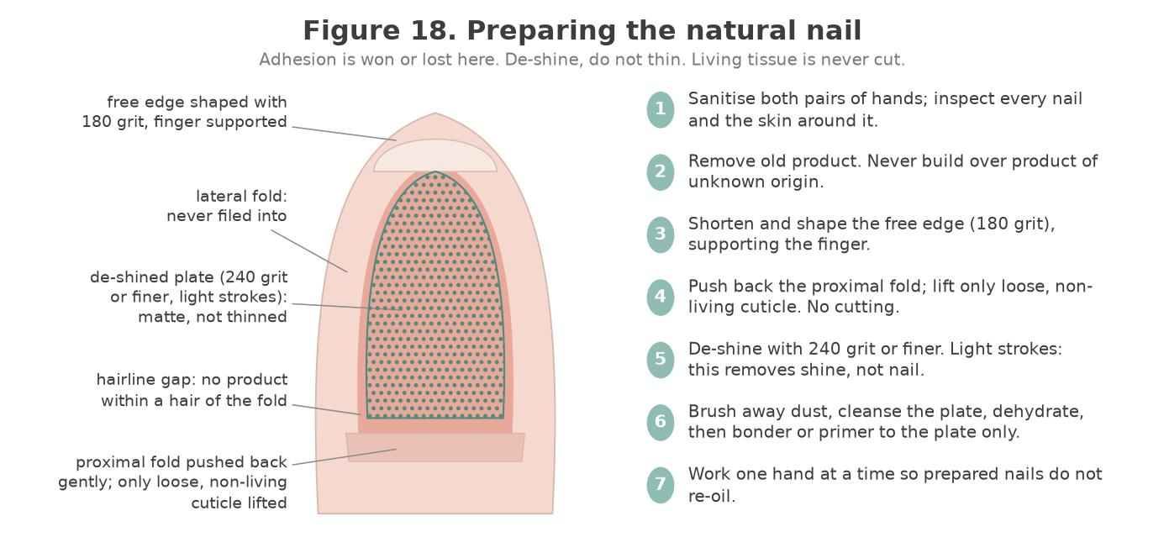
Figure 18. Preparing the natural nail: the free edge shaped, the proximal fold pushed back, only loose non-living cuticle lifted, the plate de-shined with a fine buffer, and a hairline gap kept at every fold.
Original illustration © The Looking Glass Beauty School, 2026.
Preparation fault | Consequence
Cuticle tissue left on the plate | Lifting at the base within days.
Oil or hand cream on the plate | Immediate adhesion failure.
Over-buffed, thinned plate | Sensitivity, weakness, and a higher heat-spike risk.
Product on living skin | Irritation and a direct route to sensitisation.

Chapter 12 — Applying builder gel: slip layer, structure and apex
Controlling a product that wants to move

The slip layer
A slip layer is a very thin first layer of builder gel, applied like a base coat and cured. It gives the structural layer something to key into and improves adhesion on nails that lift easily. Some systems require it; some allow a scrub layer of the builder gel itself instead of a separate base coat. Follow your product.

Building the structure
- Apply the slip or scrub layer thinly, working it into the plate, and cure for the time the product specifies.
- Place a bead of builder gel just behind the stress area, where the apex will sit — in the back third of the nail.
- Guide the product towards the free edge and the sidewalls with the brush, leaving a hairline gap from the living tissue at the cuticle area.
- Turn the client's finger downwards and let the product self-level for a few seconds, watching the apex form. This is the moment the structure is decided.
- Flash cure for a few seconds to freeze the shape, then return the hand to the lamp for the full cure.
- Check the apex from the side and the C-curve from the barrel. Build a second layer if needed rather than trying to achieve everything in one.
- Cure fully, then cleanse the inhibition layer with a fresh lint-free wipe and the specified cleanser.
- Refine with a 180 grit file, re-cleanse, and finish with the top coat the system specifies.
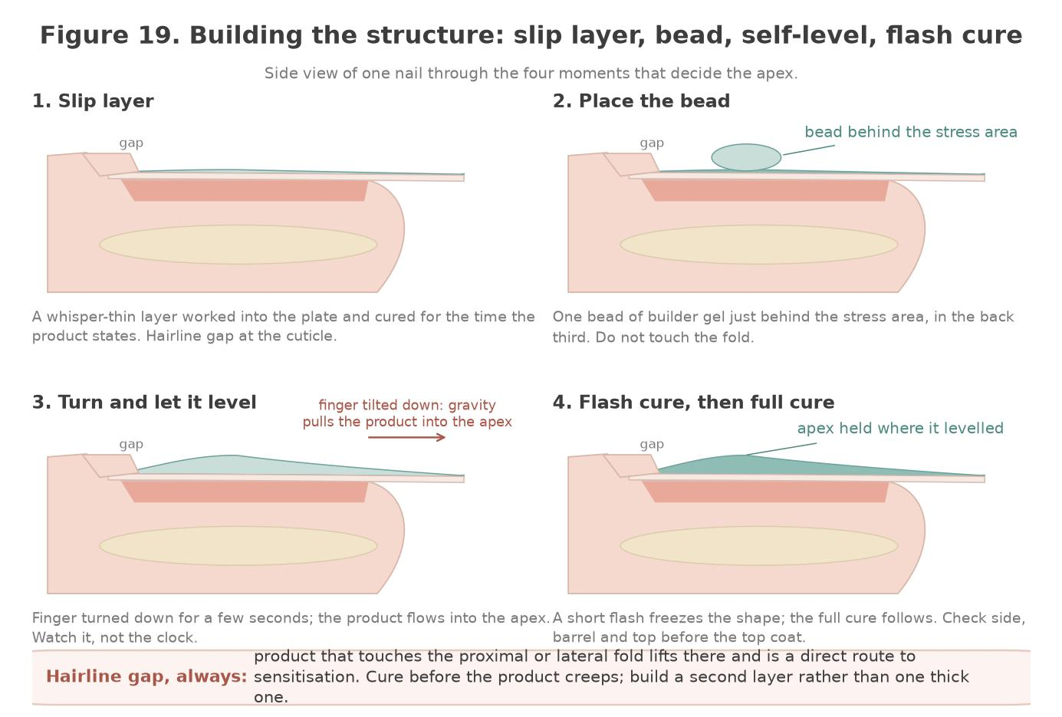
Figure 19. Building the structure in four moments: the thin slip layer, the bead placed just behind the stress area, the finger turned so the product levels into the apex, and the flash cure that holds the shape before the full cure.
Original illustration © The Looking Glass Beauty School, 2026.
THE HAIRLINE GAP — Builder gel flows. A product that touches the proximal or lateral folds will lift there and is a direct sensitisation risk. Leave a deliberate hairline gap and cure before the product creeps.

Reading the product as you work
What you see | What it means | What to do
Product floods the cuticle area | Too much product, or left too long before curing | Remove it with the brush now; flash cure earlier next nail.
The apex flattens out before you cure | Product too thin or too fluid for the structure you want | Build in two layers; flash cure to hold the shape.
Product slides to one sidewall | Finger not held level; gravity | Control the hand position and rotate the finger as it levels.
Surface sets but stays soft underneath | Layer too thick; light not reaching the base | Thinner layers, full cure time, check lamp compatibility.
Client reports heat | Heat spike | Hand out of the lamp immediately. See Chapter 6.

Chapter 13 — Short extensions on a tip or form
Adding length within what the product can support
Builder gel can create short extensions where the manufacturer states it. 'Short' is the operative word: the flexibility that makes builder gel comfortable on a natural nail becomes a weakness at length. Check your product's stated capability and stay inside it.

On a tip
- Select a tip matching the natural nail sidewall to sidewall, and check the C-curve matches.
- Apply adhesive to the well of the tip, place at a shallow angle, roll down and hold.
- Blend the join with a 180 grit file until it cannot be felt, filing the tip only.
- Cut and shape to the agreed length before applying builder gel.
- Apply the builder gel over the whole nail and tip, building the apex behind the stress area.

On a form
- Fit the form under the free edge with no gap and without pinching the sidewalls.
- Check the angle from the side and the symmetry from underneath.
- Build the extension in layers, curing each, rather than attempting the full length at once.
- Build the apex behind the stress area, not out on the extension.
- Remove the form by unpeeling, then refine the underside and check the C-curve.
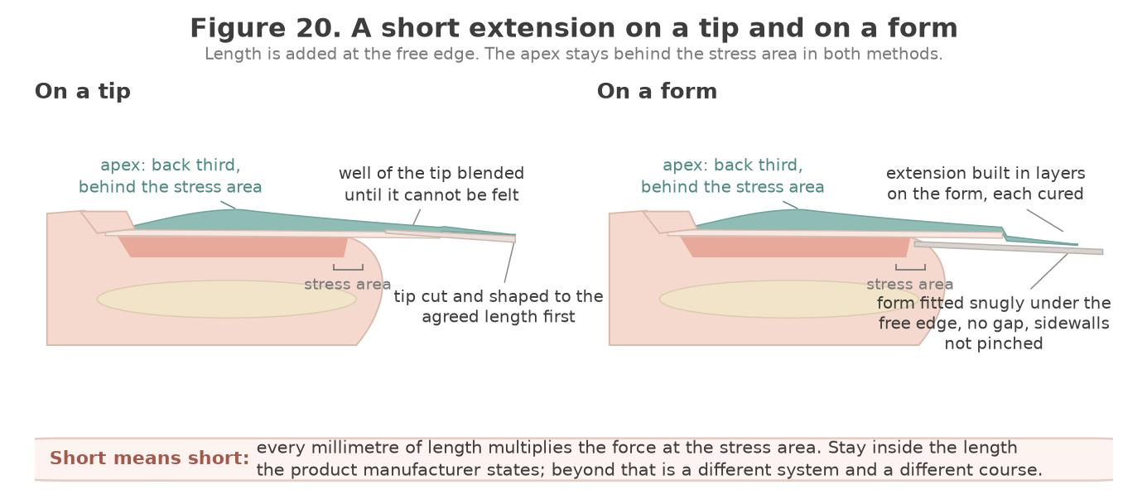
Figure 20. A short extension on a tip (left) and on a form (right). The tip is blended and shaped before any gel is applied; the form is fitted without a gap and the extension built in cured layers. In both the apex stays in the back third, behind the stress area.
Original illustration © The Looking Glass Beauty School, 2026.
LENGTH AND LEVERAGE — Every millimetre of added length increases the force at the stress area. If a client wants length beyond what builder gel supports, the honest answer is a different system and a different professional, not a longer builder-gel nail.

Chapter 14 — Infills, rebalance, repairs and removal
Maintaining the structure, and taking it off safely

Infill and rebalance
- Assess every nail before filing. Record lifting, cracks, discolouration and skin changes.
- Remove any lifted product completely. Never build over a lifted edge.
- Reduce the bulk of the existing overlay and lower the old apex so the new one can sit correctly.
- Blend the regrowth area to a smooth transition with no ledge.
- Prepare the exposed natural nail as in Chapter 11.
- Rebuild the structure, repositioning the apex in the back third.
- Cure, cleanse, refine, finish and record.
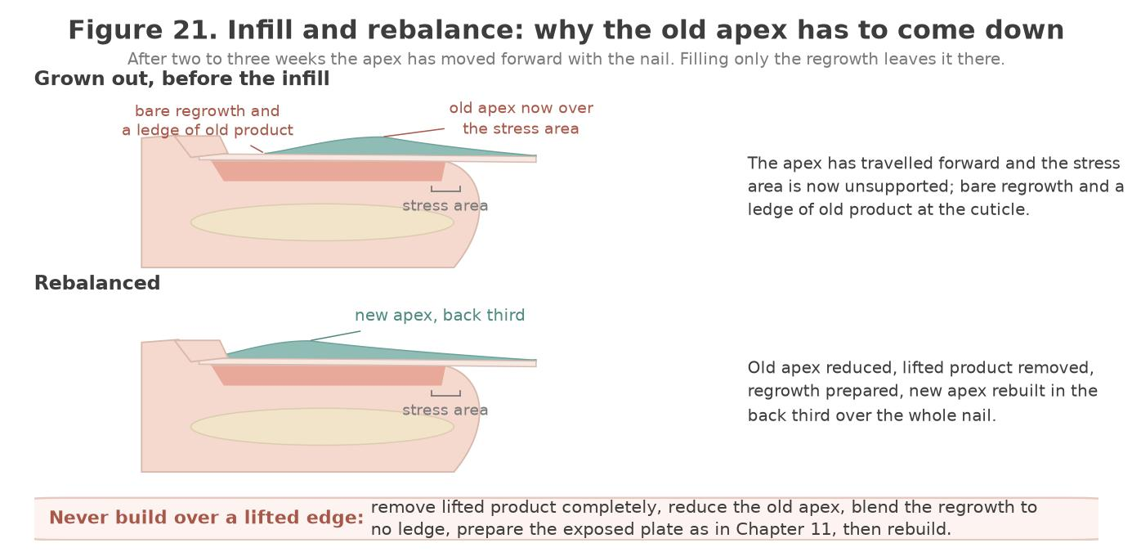
Figure 21. Infill and rebalance. Growth carries the old apex forward over the stress area; a rebalance reduces it, prepares the regrowth and rebuilds the apex in the back third over the whole nail.
Original illustration © The Looking Glass Beauty School, 2026.

Removal — know your product first
Builder gels are not all removed the same way. Using the wrong method is how natural nails get damaged: soaking a file-off product wastes twenty minutes and achieves nothing, while filing a soak-off product down to the plate removes nail with it.
Removal category | Method | Warning
Soak-off | Reduce the bulk, then soak in acetone as the product specifies, removing softened product gently with a wooden tool | Re-soak rather than scraping product that is still hard.
File-off | Reduce carefully to a thin layer with a 100/180 file, then buff the remainder away | Stop at the natural nail. Filing into the plate is the single most damaging thing you can do.
Combination | Reduce by file, then soak the remainder | Follow the manufacturer's instruction.

NEVER PRISE OR NIP — Levering product off takes layers of nail plate with it. Damage clients blame on the product is almost always damage caused by removal.

Chapter 15 — Longevity and troubleshooting
Reading a service that has gone wrong
Problem | Likely cause | Prevention
Lifting at the cuticle area | Cuticle tissue left on the plate, or product flooded onto skin | Thorough preparation; hairline gap; cure before the product creeps.
Lifting at the free edge | Free edge not capped, or product not sealed | Cap the free edge on every nail.
Product peels off in a sheet | Under-cured, or a lamp that does not match the product | Correct lamp, full cure time, thin layers.
Soft or tacky after full cure | Under-cure, expired product, or light-degraded product | Check lamp and product age; keep bottles closed and out of light.
Apex in the wrong place or absent | Product cured before it levelled, or not rebalanced at infill | Flash cure at the right moment; rebalance every time.
Cracking at the stress area | Apex too far forward, or overlay too thin | Build the apex in the back third; build in layers.
Client reports heat during cure | Heat spike | Hand out of the lamp immediately; thinner layers; flash cure.
Green discolouration under the product | Moisture trapped under a lifted area | Never infill over lifting; follow the referral procedure in Chapter 4.
Client reports itching or swelling around the nails | Possible acrylate sensitisation | Stop, remove safely, refer for medical assessment, do not reapply.

Setting expectations honestly
- Two to three weeks between infills is normal and is not a service failure.
- Builder gel protects the free edge so it is not broken off; it does not make nails grow faster.
- Flexibility is designed in. A builder-gel nail that bends slightly is behaving correctly.
- The natural nail is not damaged by builder gel correctly applied and correctly removed.
- Never promise a number of days of wear. Explain what affects it and record what you advised.

Chapter 16 — Contra-actions, adverse reactions and emergencies
Recognise early signs, stop exposure and escalate appropriately

Contra-action or adverse reaction?
A contra-action is an unwanted response or service problem during or after treatment, such as heat discomfort, minor accidental skin abrasion, lifting or dryness. An adverse reaction is a harmful response to a product or process and may include irritant dermatitis, allergic contact dermatitis, respiratory symptoms, chemical eye exposure or burns. The professional does not diagnose the mechanism; they recognise signs, stop exposure, give proportionate first aid and refer.
Event | Possible signs | Immediate management
Brief warmth/heat spike | Warmth or sharp burning during cure | Ask client to remove hand briefly if burning; stop/reassess; use manufacturer heat protocol; never tell client to tolerate pain
Product on skin before cure | Visible uncured gel in fold/on skin | Remove completely with clean tool/wipe; wash contamination from skin as appropriate; do not cure until skin is clean
Minor skin break/bleeding | Nipper/file injury | Stop; first aid and blood procedure; do not apply gel; document; refer if needed
Irritant contact reaction | Burning, redness, dryness or cracking after chemical contact | Stop exposure; remove wet product; wash with soap/water; follow SDS; advise medical/pharmacy help if persistent
Suspected allergic contact dermatitis | Itching, swelling, redness, blistering, fingertip changes; may affect eyelids/face/neck | Stop all relevant nail product exposure; do not re-test; advise GP/dermatology assessment; document product/lamp/batch
Eye exposure | Stinging, watering, redness or product splash | Follow SDS immediately; irrigate with clean lukewarm water for specified time, remove contact lenses if easy, obtain urgent medical advice
Respiratory symptoms | Cough, wheeze, chest tightness, dizziness or shortness of breath | Stop work, move to fresh air if safe, follow SDS/emergency plan. Call 999 for severe breathing difficulty or collapse
Severe allergic/emergency signs | Rapid facial/throat swelling, breathing difficulty, collapse, confusion | Call 999 immediately; follow emergency/first-aid training; do not leave the person alone
Post-service lifting/chipping | Coating separates or chips | Assess promptly. Remove lifted area/product; inspect for moisture/discolouration; repair only when healthy
Possible infection after service | Increasing pain, heat, swelling, pus, spreading redness or green discolouration | Do not treat or cover; advise urgent pharmacy/GP/NHS 111 assessment; emergency care if systemically unwell

General adverse-reaction response
- STOP the treatment and prevent further exposure.
- REMOVE uncured/wet product safely without spreading it; do not use additional sensitising solvents on skin unless the SDS directs.
- RINSE/WASH or provide first aid according to the exact product SDS and first-aid training.
- ASSESS urgency. Call 999 for emergency signs; otherwise advise NHS 111, GP, pharmacist or occupational health as appropriate.
- RECORD factual signs, times, affected area, product names/batches, lamp/model/cure, PPE, action, advice and witnesses. Photograph only with consent and without delaying care.
- REPORT internally, to insurer and under RIDDOR/OPSS rules where applicable. Preserve product/records; do not alter notes.
- REVIEW the COSHH assessment, product system, lamp, training and technique before any further service. Do not perform a salon 'patch test' to prove safety.

Allergy prevention for professionals
- Keep uncured product off your own skin and the client's skin every time, not only when a reaction is suspected.
- Use controlled dispensers/brushes, clean bottle necks and avoid wiping gel onto gloves, towels or lamp surfaces.
- Change contaminated gloves immediately and select glove material/change intervals from the SDS/COSHH assessment.
- Do not touch your face, phone, pen or door handles with contaminated gloves.
- Use extraction for dust and prevent airborne/residual gel contamination during filing/removal.
- Report hand eczema, cracking, eyelid/facial rash, cough or wheeze early. Once sensitised, continued exposure can jeopardise a technician's career and future medical/dental choices.

Chapter 17 — Aftercare and professional client support
Clear advice protects the service and the natural nail

Aftercare advice
- Apply cuticle oil to intact skin daily and massage around, not beneath, the enhancement. Stop if irritation occurs.
- Wear suitable gloves for prolonged wet work, cleaning, gardening and chemical exposure; dry hands thoroughly afterwards.
- Do not pick, peel, bite or prise the coating. Do not use nails as tools to open cans, scrape labels or lift objects.
- Keep the chosen length practical. If an edge catches, contact the nail professional; do not tear it or glue a damaged natural nail without advice.
- Book professional removal/reapplication according to growth, condition and product guidance, commonly around 2–3 weeks.
- Contact the salon promptly for lifting, a crack, trapped moisture, green/black/yellow change, unexpected white/powdery area or significant chip.
- Stop product exposure and seek advice for itching, redness, swelling, blistering, burning, fingertip changes or rash on hands/face/eyelids. Seek emergency help for breathing or throat/facial swelling.
- Do not cover a changed nail with ordinary polish or another enhancement before it has been assessed.
- Acetone removal may leave skin/nails temporarily dry; moisturise intact skin and keep nails short if not reapplying.
- Results vary: aftercare supports wear but cannot make an overlay indestructible or guarantee a fixed number of days.

Written aftercare handout
CLIENT TAKEAWAY — LOOK AFTER YOUR OVERLAY: Oil intact cuticle skin daily. Wear gloves for wet/chemical work. Never pick or peel. Keep nails at a practical length. Book professional removal. Contact us for lifting, damage, colour change or discomfort. Stop exposure and seek medical advice for a suspected reaction; call 999 for breathing difficulty, collapse or rapid face/throat swelling.

Professional follow-up
- Record the advice given and the recommended review/removal date.
- Invite the client to report early problems without blame. Early lifting can be removed before moisture is trapped.
- At the next visit, compare wear with the previous plan and adjust length, shape, preparation or system only for a clear reason.
- Do not repeatedly repair the same failure without investigating product compatibility, equipment, technique, nail condition and lifestyle.
- Document complaints factually, preserve photographs/product records and follow the salon's complaint and insurer-notification procedure.
TEACH-BACK ACTIVITY In pairs, give the client aftercare in 60 seconds. The listener checks that you covered professional removal, wet-work protection, no picking, early reporting of lifting or colour change, and urgent reaction signs. Swap roles and improve one phrase.

Chapter 18 — Course conclusion and next steps
Bringing the learning together before you work on your own clients

What you have covered
Chapter 1 set out ten learning outcomes. By the end of the taught day, and once your three case studies are complete, you should be able to:
- say what builder gel is for, who it suits, and when gel polish, hard gel or acrylic is the honest answer (LO1);
- name the structures of the nail unit and recognise the conditions that mean adapt, postpone or refuse (LO2);
- consult, record and gain informed consent, and write a treatment plan another professional could follow (LO3);
- explain how gel cures: photoinitiators, lamp compatibility, under-curing and the inhibition layer (LO4);
- explain why builder gel carries a heat-spike risk that gel polish does not, and control it (LO5);
- select, handle, store and dispose of products and equipment under COSHH and the manufacturer's instructions (LO6);
- prepare the natural nail without damage to the plate or living tissue (LO7);
- build a balanced overlay with the apex in the back third, straight sidewalls and an even C-curve (LO8);
- create a short extension on a tip or form within what the product allows (LO9);
- infill, rebalance and remove builder gel safely by the method the product requires, and give aftercare (LO10).

Questions, feedback and reflection
Ask anything you are unsure of before you leave; there is no question too small when the alternative is guessing on a paying client. At the end of the taught day you will complete an evaluation form, and your reflective practice form goes into your portfolio with the case studies; both are in the Tutor and Assessor Pack. Reflection is part of continuing professional development: it is how a day's training becomes a change in the way you work. Your feedback also shapes the next version of this course.

What happens next
- Your CPD certificate is issued by The Looking Glass Beauty School once the theory paper, the practical observation and all three case studies are satisfactory. It carries the course title exactly as accredited and the CPD hours.
- Before offering the service commercially, confirm with your insurer that this CPD course, your underlying qualification and your working arrangements are accepted, and check your local authority's requirements (Chapter 10).
- Complete Form G, the product and lamp compatibility record, for the system you will use in your own salon, before your first paying client.
- Start with short overlays on healthy natural nails. Add tips and forms once your overlays are consistent from every angle.

Continuing your development
Builder gel sits in the middle of the nail systems compared in Chapter 2. The natural next steps at The Looking Glass Beauty School are the Gel Polish CPD Course for colour services on the natural nail, the Liquid and Powder Acrylic Enhancement CPD Course for strength and length beyond what builder gel supports, and nail art. Support continues after the course: contact the school by phone, message or email with questions about products, technique or a client you are unsure about. We would rather hear from you than have you guess. Details of every course and how to book are on the school's website and social media.
THANK YOU — for choosing The Looking Glass Beauty School. Work within your scope, keep the product off the skin, listen to the client under the lamp, and the rest is practice.

Chapter 19 — Learner activities and knowledge checks
Work through these before, during and after the taught day

Before the taught day
- Read Chapters 1 to 10 and note three questions to bring with you.
- Obtain the Safety Data Sheet for the builder gel you will use. Record the product name, its removal category and its stated extension capability.
- Find the make, model and wattage of the lamp you will use, and its cure schedule for this product.
- Write, in your own words, what a heat spike is and exactly what you would do if a client reported one.

Knowledge checks
# | Question
1 | Explain what a photoinitiator does and why lamp compatibility matters.
2 | Name three things that change when a gel layer is applied thicker.
3 | What is a heat spike, why does builder gel carry more risk of it than gel polish, and what do you do?
4 | What is a slip layer and what is it for?
5 | Where does the apex belong, and what happens if it is too far forward?
6 | Why is a hairline gap at the cuticle area correct technique?
7 | Name the three removal categories of builder gel and the risk of using the wrong method.
8 | Explain the difference between an infill and a rebalance.
9 | Why is 'BIAB' not used as the course title?
10 | A client's overlay peels off in one sheet after four days. Give three possible causes and how you would tell them apart.
11 | Explain why acrylate sensitisation is a greater risk to you than to your client.
12 | A client wants 15 mm extensions in builder gel. Explain your answer.

SCENARIO A — Two nails have lifted at the cuticle and one has green discolouration under a lifted corner. Set out your assessment, what you do to each nail, what you say, and what you record.
SCENARIO B — Halfway through a set, a client pulls her hand out of the lamp and says her finger is burning. Describe exactly what you do next, what you change for the remaining nails, and what goes in the record.
SCENARIO C — A client booked a 'BIAB infill' and brings in product applied elsewhere. You do not know the brand or its removal category. Explain how you proceed.

After the taught day
- Complete three case studies as described in Chapter 1.
- For each, record the product and lamp used, cure times, the structure achieved, the aftercare given and one thing you would do differently.
- Photograph each set from above, from the side and from the barrel view, with consent.

Chapter 20 — Learner forms and client records
Templates to evidence consultation, planning, aftercare and case studies
DATA PROTECTION These forms collect personal and sometimes special-category health data. Do not ask for information that is not necessary for treatment safety.

Form A — Builder gel consultation and treatment plan
Provider data-protection details
Data controller (school/salon name) | ____________________________________________________________________
ICO registration reference | ____________________________________________________________________
Privacy notice location | ____________________________________________________________________
Lawful basis and special-category condition | ____________________________________________________________________
Retention period | ____________________________________________________________________

Template: the school or salon completes this block before the form is used with clients.
Client/model full name | ____________________________________________________________________
Date of birth / confirmation aged 18+ | ____________________________________________________________________
Telephone or preferred contact | ____________________________________________________________________
Date and time | ____________________________________________________________________
Technician/learner | ____________________________________________________________________

Desired result and lifestyle
 | ____________________________________________________________________
Work and hand-use considerations | ____________________________________________________________________
Wet work/chemicals/sport/hobbies | ____________________________________________________________________
Previous gel service and typical wear | ____________________________________________________________________
Previous removal method and any damage | ____________________________________________________________________

Relevant health, allergy and nail questions
Relevant question | Yes/No | Necessary details
Have you ever had itching, redness, swelling, blistering, nail lifting or rash after gel, acrylic, nail glue, adhesive or dental material?
Do you currently have pain, heat, swelling, broken skin, rash, discharge or colour change around any nail?
Have you been diagnosed with a nail/skin condition that affects this treatment area? If yes, what treatment limitation has been advised?
Are you taking medication or receiving treatment that has recently changed your skin, nails, healing or sensitivity? Record only relevant details.
Do you have diabetes, impaired circulation, reduced sensation, immune suppression or another factor that requires extra care?
Is there anything else relevant to your ability to use the lamp, remain positioned or follow aftercare?

Professional nail and skin assessment
Area | Observation | Proceed/adapt/postpone/refer
Nail plates
Nail folds/cuticle
Free edges/hyponychium
Colour/attachment
Skin integrity
Other

Agreed treatment plan
System and named products | ____________________________________________________________________
Lamp make/model and cure schedule | ____________________________________________________________________
Preparation/adaptations | ____________________________________________________________________
 | ____________________________________________________________________
Removal/review date | ____________________________________________________________________
Price | ____________________________________________________________________
Aftercare supplied | ____________________________________________________________________

Treatment consent: I confirm that I have answered the relevant consultation questions honestly, had the planned builder gel service, foreseeable risks, alternatives, aftercare and costs explained, and had an opportunity to ask questions. I understand that results and wear vary and that I may ask the professional to stop at any time.
Client/model signature and date | ____________________________________________________________________
Technician/learner signature and date | ____________________________________________________________________
Tutor signature if assessed | ____________________________________________________________________

Data notice/condition: I have received or can access the provider's privacy notice. Where the provider relies on explicit consent to process relevant health data, that consent must be recorded separately and must meet ICO requirements.
Relevant data-processing record / explicit-consent statement if used ____________________________________________________________________

Form B — Separate photograph consent
Photograph consent is optional and separate from treatment consent. Tick each use agreed. Refusing marketing use must not affect access to treatment.
- ☐ Assessment evidence viewed by The Looking Glass Beauty School educator/quality assurer.
- ☐ Accreditation evidence viewed by the accrediting body where required.
- ☐ Anonymous learner portfolio (no face/name/identifying jewellery).
- ☐ The Looking Glass Beauty School website/social media/marketing.
- ☐ The salon's website/social media/marketing.
How long images will be retained | ____________________________________________________________________
How consent can be withdrawn for future use | ____________________________________________________________________
Model name | ____________________________________________________________________
Model signature/date | ____________________________________________________________________
Learner/educator signature/date | ____________________________________________________________________

Form C — Treatment record
Record field | Details
Date / technician
Consultation changes
Nail condition before service
Lamp model and exact cure times
Preparation and service steps
Variations/contra-actions
Outcome
Aftercare and review date
Client comments
Signatures | ______________________________

Form D — Three-case-study log

Case study 1
Model code/name | ____________________________________________________________________
Date | ____________________________________________________________________
Service and goal | ____________________________________________________________________
Nail/skin assessment | ____________________________________________________________________
Product system and lamp | ____________________________________________________________________
Cure schedule | ____________________________________________________________________
Preparation/adaptations | ____________________________________________________________________
Outcome and photograph filenames | ____________________________________________________________________
Aftercare | ____________________________________________________________________
What went well | ____________________________________________________________________
What I would improve | ____________________________________________________________________
Follow-up/wear result | ____________________________________________________________________
Educator feedback | ____________________________________________________________________
Result: Satisfactory / Further evidence required | ____________________________________________________________________

Case study 2
Model code/name | ____________________________________________________________________
Date | ____________________________________________________________________
Service and goal | ____________________________________________________________________
Nail/skin assessment | ____________________________________________________________________
Product system and lamp | ____________________________________________________________________
Cure schedule | ____________________________________________________________________
Preparation/adaptations | ____________________________________________________________________
Outcome and photograph filenames | ____________________________________________________________________
Aftercare | ____________________________________________________________________
What went well | ____________________________________________________________________
What I would improve | ____________________________________________________________________
Follow-up/wear result | ____________________________________________________________________
Educator feedback | ____________________________________________________________________
Result: Satisfactory / Further evidence required | ____________________________________________________________________

Case study 3
Model code/name | ____________________________________________________________________
Date | ____________________________________________________________________
Service and goal | ____________________________________________________________________
Nail/skin assessment | ____________________________________________________________________
Product system and lamp | ____________________________________________________________________
Cure schedule | ____________________________________________________________________
Preparation/adaptations | ____________________________________________________________________
Outcome and photograph filenames | ____________________________________________________________________
Aftercare | ____________________________________________________________________
What went well | ____________________________________________________________________
What I would improve | ____________________________________________________________________
Follow-up/wear result | ____________________________________________________________________
Educator feedback | ____________________________________________________________________
Result: Satisfactory / Further evidence required | ____________________________________________________________________

Form E — Adverse reaction / incident record
Client/learner/staff name | ____________________________________________________________________
Date/time/location | ____________________________________________________________________
Treatment stage | ____________________________________________________________________
Factual signs and symptoms | ____________________________________________________________________
Affected nail/skin/area | ____________________________________________________________________
Product names, batches and SDS | ____________________________________________________________________
Lamp model and cure details | ____________________________________________________________________
PPE and ventilation in use | ____________________________________________________________________
Immediate action/first aid | ____________________________________________________________________
Emergency service/NHS 111/GP/pharmacist advice | ____________________________________________________________________
Witnesses | ____________________________________________________________________
Photograph consent/file reference | ____________________________________________________________________
Insurer/internal/RIDDOR/OPSS notification decision | ____________________________________________________________________
Follow-up and risk-assessment review | ____________________________________________________________________
Completed by/signature/date | ____________________________________________________________________

Form F — Cleaning and equipment log
Date/time | Item/area | Clean/disinfect/sterilise | Product/cycle/contact time | Completed by | Fault/action

Form G — Product and lamp compatibility record
This record is completed twice: first during training, using the system the tutor demonstrates, and again by the learner for their own kit before offering the service commercially.
 | Lamp make/model | Output stated | Cure time | Manufacturer evidence/source | Date checked

Form H — Learner declaration
I understand the scope of this CPD activity and will not describe it as a regulated qualification. I will work only within my underlying qualifications, competence, insurer and local requirements; use compatible products and lamps; avoid skin exposure; refuse suspected infection/reaction; and maintain accurate client and product records.
Learner name | ____________________________________________________________________
Signature | ____________________________________________________________________
Date | ____________________________________________________________________
Educator name/signature | ____________________________________________________________________

Chapter 21 — References and further reading
Authoritative sources used for technical and regulatory checking
Legislation and guidance can change; the provider reviews this list at least annually and whenever a product, lamp, insurer rule, local-authority condition or official safety alert changes.
- UK Parliament — Health and Safety at Work etc. Act 1974 — 1974 — https://www.legislation.gov.uk/ukpga/1974/37
- UK Parliament — Control of Substances Hazardous to Health Regulations 2002 — 2002 — https://www.legislation.gov.uk/uksi/2002/2677
- Health and Safety Executive — COSHH Essentials sheet SR13: Nail bars and other beauty services — 2025 — https://www.hse.gov.uk/pubns/guidance/sr13.pdf
- UK Parliament — Personal Protective Equipment at Work Regulations 1992 (as amended by the Personal Protective Equipment at Work (Amendment) Regulations 2022) — 1992/2022 — https://www.legislation.gov.uk/uksi/1992/2966
- Health and Safety Executive — Personal protective equipment (PPE) at work guidance — 2022 — https://www.hse.gov.uk/ppe/
- UK Parliament — Reporting of Injuries, Diseases and Dangerous Occurrences Regulations 2013 (RIDDOR) — 2013 — https://www.legislation.gov.uk/uksi/2013/1471
- Health and Safety Executive — RIDDOR: occupational diseases — n.d. — https://www.hse.gov.uk/riddor/
- UK Parliament — Electricity at Work Regulations 1989 — 1989 — https://www.legislation.gov.uk/uksi/1989/635
- Health and Safety Executive — Portable appliance testing (PAT) FAQs — n.d. — https://www.hse.gov.uk/electricity/faq-portable-appliance-testing.htm
- UK Parliament — Waste Electrical and Electronic Equipment Regulations 2013 — 2013 — https://www.legislation.gov.uk/uksi/2013/3113
- UK Parliament — Data Protection Act 2018 (with UK GDPR) — 2018 — https://www.legislation.gov.uk/ukpga/2018/12
- Information Commissioner's Office — Special category data: guidance — n.d. — https://ico.org.uk/for-organisations/uk-gdpr-guidance-and-resources/lawful-basis/special-category-data/
- Information Commissioner's Office — How should we obtain, record and manage consent? — n.d. — https://ico.org.uk/for-organisations/uk-gdpr-guidance-and-resources/lawful-basis/consent/
- Information Commissioner's Office — Data protection fee — n.d. — https://ico.org.uk/for-organisations/data-protection-fee/
- UK Parliament — Consumer Rights Act 2015 — 2015 — https://www.legislation.gov.uk/ukpga/2015/15
- UK Parliament — Cosmetic Products Enforcement Regulations 2013 — 2013 — https://www.legislation.gov.uk/uksi/2013/1478
- UK Parliament — London Local Authorities Act 1991 (special treatment licences) — 1991 — https://www.legislation.gov.uk/ukla/1991/13
- UK Parliament — Local Government (Miscellaneous Provisions) Act 1982 — 1982 — https://www.legislation.gov.uk/ukpga/1982/30
- UK Parliament — Civic Government (Scotland) Act 1982 — 1982 — https://www.legislation.gov.uk/ukpga/1982/45
- Welsh Parliament — Public Health (Wales) Act 2017 (special procedures) — 2017 — https://www.legislation.gov.uk/anaw/2017/2
- European Commission — Commission Regulation (EU) 2020/1682 (HEMA and di-HEMA TMHDC restriction, professional use only; as retained in the GB Cosmetics Regulation) — 2020 — https://www.legislation.gov.uk/eur/2020/1682
- European Parliament and Council — Regulation (EC) No 1223/2009 on cosmetic products (applies in Northern Ireland) — 2009 — https://eur-lex.europa.eu/legal-content/EN/TXT/?uri=CELEX%3A02009R1223-20250901
- UK Government — The Cosmetic Products Regulation (EC) No 1223/2009 (Restriction of Chemical Substances) (Amendment and Transitional Provisions) Regulations 2026, SI 2026/23 — TPO inserted as entry 1745 of Annex II; regulation 2(3) in force 15 August 2026, with transitional provision to 14 February 2027 — https://www.legislation.gov.uk/uksi/2026/23/made
- UK Government — The Cosmetic Products Regulation (EC) No 1223/2009 (Restriction of Chemical Substances) (Amendment and Transitional Provisions) (No. 2) Regulations 2026, SI 2026/109 — further Annex II and Annex III amendments — https://www.legislation.gov.uk/uksi/2026/109/made
- British Beauty Council — What does the EU ban on TPO gel nail polish mean for manicurists? — 2025 — https://britishbeautycouncil.com/what-does-the-eu-ban-on-tpo-gel-nail-polish-mean-for-manicurists/
- British Association of Dermatologists — Dermatologists issue warning about UK artificial nail allergy epidemic — 2018 — https://www.bad.org.uk/dermatologists-issue-warning-about-uk-artificial-nail-allergy-epidemic
- British Society for Cutaneous Allergy — Acrylate allergy patient information — n.d. — https://www.cutaneousallergy.org/
- NHS — Nail problems — n.d. — https://www.nhs.uk/conditions/nail-problems/
- NHS — Fungal nail infection — n.d. — https://www.nhs.uk/conditions/fungal-nail-infection/
- Advertising Standards Authority / Committee of Advertising Practice — Beauty and cosmetics: general advice online — n.d. — https://www.asa.org.uk/advice-online/beauty-and-cosmetics-general.html
- Cosmetic, Toiletry and Perfumery Association — Guidance on nail products — n.d. — https://www.ctpa.org.uk/
- Skills England (formerly Institute for Apprenticeships and Technical Education) — Nail services technician occupational standard — n.d. — https://www.instituteforapprenticeships.org/apprenticeship-standards/nail-services-technician/
All references checked 23 September 2026 as part of the scheduled document review.

